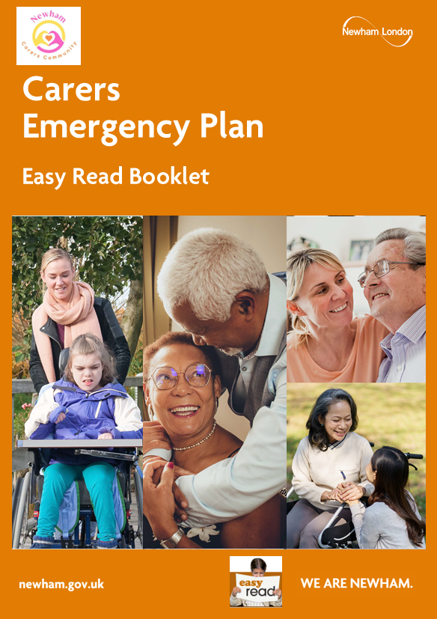

Introduction

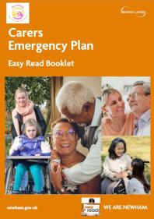
This leaflet talks about what an emergency care plan is for carers.

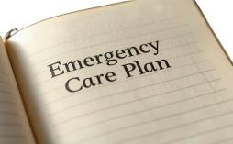
An emergency care plan can help a carer get ready in case something unexpected happens and you can't care for the person you usually look after.


If you need help with completing this plan, please contact Newham Carers Community by calling, 020 3954 3143

or email info@newhamcarerscommunity.org.uk

What counts as an emergency?

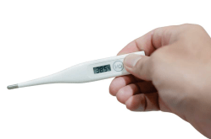
An emergency is anything that happens suddenly and stops you from providing care. This could include:

- You become ill or have an accident.


- You are admitted to hospital without warning.


- A family emergency comes up.

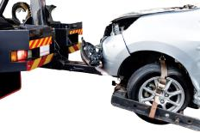
- Travel problems like a broken-down car or cancelled flight.

What should I do after I complete an emergency care plan?


- Speak with the person you care for, if you can.

- Talk to your emergency contacts - these can be trusted family members or friends.

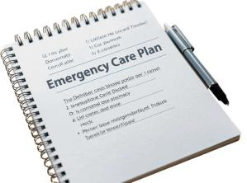
- Make sure they know what's in the emergency care plan and what to do.

Send Your Form

- When your plan is ready, email it to: HSG.ControlRoom@newham.gov.uk.

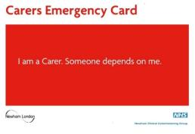
- Newham Network will then send you your Carers Emergency Card. It has a number people can call to get help quickly using your emergency plan.

Share and Update

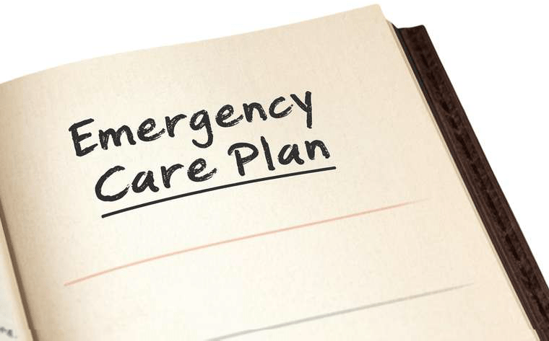
- Give a copy of your emergency care plan to your emergency contacts - or let them know where to find it.


- Check the emergency care plan often and keep it up to date.

Carer’s Details
Please complete this emergency care plan. When complete please email to HSG.ControlRoom@newham.gov.uk.

My name
My address | Postcode:
My telephone number
My relationship to the person I care for e.g. wife, son, etc

About the person
you care for

Their name
What they like to be called (if different)
Their date of birth
Their address if different | Postcode:
Name of disability or illness
GP surgery name/contact details

Pharmacy name/contact details
(if known)
Does the person you care for receive support from  Adult Social Care? | If yes, please provide any relevant information or key contacts, including their Azeus ID number, if known
Main language spoken/understood

Does the person you care for have allergies? | If yes, please provide details.

Does the person you care for take any medicine? | If yes, please provide details such as the names of the medications, the time taken.
What is the most important help they need everyday?

Please provide any other information which may be useful to know about the person you care for, such as:

- If they use any special equipment. For example, using a walking frame
- Help that requires special training. For example, using a tube to feed
- Any memory problems or challenging behaviours
- Likes and dislikes.

Emergency Contact
Details
If there is an emergency, who can we contact?

 | Emergency Contact 1 | Emergency Contact 2 | Care Agency involved  (if known)
Name
Relationship to you
Relationship to the person you care for
Telephone number (mobile)
Telephone number (home)
Telephone number (work)

Key Holders
A key holder is someone who lives nearby and has a key to the
home of the person you care for.

They won’t need to help with care – just help with getting into the home if needed.

 | Key Holder 1 | Key Holder 2
Name
Relationship to you
Relationship to the person you care for
Telephone number (mobile)
Telephone number (home)
Telephone number (work)

Other Information/
Instructions


Newham Carers
Community


Newham Carers Community provides support to carers and young carers in Newham.

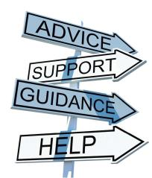
They offer free advice, information, activities and support to unpaid carers.

If you need help with completing this plan, please contact Newham Carers Community by calling,
020 3954 3143

or email info@newhamcarerscommunity
.org.uk



