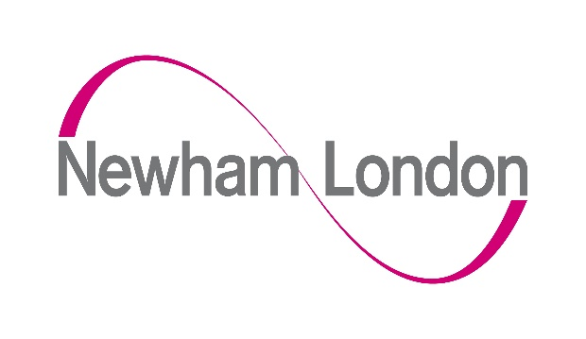

London Borough of Newham application form for temporary free school meals from families with no recourse to public funds (NRPF)
Please complete this application form if you are in one of the following categories and would like to apply for free school meals during the temporary extension as a result of the coronavirus (COVID-19) outbreak:

- A Zambrano carer
- Have the right to remain in the UK under Article 8 of the ECHR
- Receiving support under Section 4 of the Immigration and Asylum Act 1999
- Receiving support under Section 17 of the Children Act 1989 AND are subject to a NRPF condition

With exception of those receiving support under Section 4 of the Immigration and Asylum Act 1999, you must also be earning less than £16,190 per year after tax.

To fill in this form, all applicants should complete:
- part 1 and 2;
- the relevant section for their category in parts 3-6; and
- part 7, apart from those receiving support under section 4 of the Immigration and Asylum Act 1999.

When completed, please ensure the declaration at the end of the application is also signed.

Further information relating to this temporary extension is in the guidance on providing free school meals during the coronavirus (COVID-19) outbreak.

- Child’s details
Surname of child | First name(s) of child
Date of birth of child (dd/mm/yy) | Nationality of child
Address of child

- Parent/carer’s details
Surname of parent/carer | First name(s) of parent/carer
Relationship to child | Nationality of parent/carer
Address of parent/carer

Category applying under:
- Zambrano
- Article 8 ECHR
- Section 4 Immigration & Asylum
- Section 17 Children Act 1989

- Zambrano carers
If you are the holder of a derivative residents card, please share a copy. (A photograph is acceptable) If not, please sign your initials next to each of the following statements to confirm that you meet the criteria.
Carers must meet all of the following criteria to be eligible.
- I confirm that I (the carer/parent) am not a British citizen.
- I confirm that the child is a British citizen.
- I confirm that I (the carer/parent) am a direct relative or legal guardian of the child.
- I confirm that I (the carer/parent) have primary responsibility for the child.
- I confirm that there are no other people in my family in the UK who could look after the child.

Please also complete section 7.
- Leave to remain in the UK under article 8 of the ECHR
If you have leave to remain in the UK under article 8, please provide evidence of this. Evidence could include a letter from the Home Office granting you leave to remain, or a biometric residence card.
Please also complete section 7.
- Section 4 of the Immigration and Asylum Act 1999
If you are receiving section 4 support, please provide evidence of this. Evidence could include a letter from the Home Office or local authority confirming Section 4 support, and should be dated within the last six months.
People applying under this category are NOT required to complete section 7.
- Section 17 of the Children Act 1989
If you are receiving Section 17 support, please provide evidence of this such as a Child in Need letter from the local authority dated within the last six months.
Please also complete section 7.
- Evidence of earnings
To be eligible for free school meals, applicants must also be below the maximum household income threshold of £16,190. This equates to a maximum of £1,349 per month and includes any wider income or support you may be receiving in addition to any earnings from employment. Where possible, please also provide a document to show this – this could be a bank statement, a pay slip or an employment contract.
Are you employed?
If you have a partner, are they employed?
Is your annual income, including earnings from employment and any wider support you may be receiving, less than £16,190 per year?

- Declaration of applicant
I (Full Name) ..........................................................................................................

of (Current Home Address) .................................. .....................................................
confirm that the information I have provided above is accurate and true.

I agree that the information I have provided can be shared with the local authority, the Department for Education and other government departments for the purposes of assessing eligibility for a free school meal.

Parent/Carer/Guardian with legal responsibility for care of the child
- Signed
- Print name
- Date

- How to submit your completed application
  - By email to free.schoolmeals@newham.gov.uk enter the subject as NRPF FSM
OR
  - By hand to your social worker
OR
  - Post to Pupil Services (NRPF Free School Meals),
LB Newham, 1000 Dockside Road, London E16 2QU
Pupil Services aim to process all applications within 48 hours of receipt. Notification of the outcome will be sent to the applicant and their child’s current school.

