2023-2028 Property Licensing Scheme (Cabinet & DLUHC approved) | Aims and objectives of the approved third licensing scheme | PSH Service- Progress update Jan 2023- March 2026 for Year 3 of the licensing schemes including cumulative Year 1 & 2 figures. | On track for 23-28 targets?
Objective | How we aim to deliver over 2023-2028 period | Performance indicators and evidence
1. To continue with an active enforcement programme against criminal and exploitative landlords with targeted outcomes | - All HMOs will be audited or inspected over the lifetime of the licensing scheme to ensure the quality and safety of rented accommodation and that they meet property licensing requirements and subject to no further lockdown restrictions  - Using the full range of enforcement powers as set out in our enforcement policy (Appendix 5) to ensure licensing compliance and bring about improvement. This will include the investigation of wrong licence types, failures to licence, HMOs without planning permission, “beds in sheds”, waste issues, pest control issues, targeted operational visits and licence audit breaches.  - Continuing to monitor and to undertake enforcement activity under the licensing schemes. | - Over 3,127 additional and mandatory licence applications were processed and issued.  - Overall, 31,950 PRS properties were inspected including for compliance (27,835), enforcement (4,115) or a desktop audit (4,600) which is an average of 937 each month.  - This led to 2,126 enforcement notices and resulted in 112 financial penalty notice which were served on non-compliant landlords or managing agents and 46 prosecutions instigated.  - £883k received in fines and fees income during 2023-31.03.2026.  - The service investigated 1,179 breaches of licensing conditions  - 7,234 licensing investigations commenced for failure to licence rental properties in Newham  See enforcement policy: enforcement-policy-2025  post-may-26-enforcement-policy  - Monthly performance monitored and shared internally with senior management | Yes
2.To ensure landlords continue to improve the conditions and management of privately rented properties across the borough | - To audit all licensed properties during the lifetime of the scheme prioritising physical inspections to properties using an intelligence and risk based assessment process  - To ensure the quality and safety of rented accommodation, our private sector housing teams are currently auditing an average of 650 properties per month and aim to scale this up to 800 per month by investing in further qualified staff.  - Improving property conditions by formal and informal enforcement action at least 300 properties per year during the lifetime of the scheme.  - Continue to monitor the number of applications licence applications received and process applications in a timely manner.  - Where property licenses are granted, the licence holder will be required to comply with a set of conditions governing the proper letting and management of the rented property; and there will be a further property check at least every 6 months. | - 31,950 property inspections, checks and audits had been completed by Year 3, representing 79.88% of the total projected 40,000 properties. This demonstrates strong progress towards the Council's objective of inspecting all licensed properties over the five-year designation period and indicates that the programme remains on track to achieve full coverage of licensed properties.  - 8,602 proactive compliance inspections were undertaken during 2025/26, averaging approximately 717 inspections per month.  - 36,738 Property Licence Applications received  - Issued over 36,000 final Property Licences for the new scheme.  - Dealt with over 124,417 Property Licensing enquires  - First banning order in Newham for a landlord convicted of seven housing offences  - Property checks by licence holder every 6 months now included in the standard licensing conditions. | Yes
3.To improve the professionalism of the Newham landlord community by working with landlord organisations, with a view to achieving a more sustainable and self-reliant private rented housing sector in Newham | - Providing a discounted standard and early bird licence fee at the point of application for membership of accredited landlord/managing agent organisations.  - Providing voluntary training and relevant support and information to landlords via Landlord forums held at least biannually, and updates through e-bulletins emailed to all consented landlords on the Council database. We currently have consent for general communications to 17,000 of 26,000 licence holders who have opted to receive communications from the Council, and continue to encourage more licence holders to opt in.  - In line with the Mayor’s 2022 Manifesto, incentivise improved property standards so that landlords have to provide quality housing that is safe and well managed. | - Under third property scheme (2023-28): Selective Licensing £750 is the standard fee for up to 5-year licence. This was reduced to £400 during the early bird period. Further discounts of £50 for warmer home (EPC C or better) and £50 if a member of an accredited landlord association available. Multi property discount also available: More details on fees here  - Forums held or landlords: July 2025 and February 2026 - Landlord Forums – Landlord Resources – Newham Council and one scheduled for August 2026.  - e-bulletins sent and on LBN website: Landlord E Bulletins – Landlord Resources – Newham Council  - New landlord information page Landlord Information Pack – Landlord Resources – Newham Council with useful links for landlords  - ReachDeck Accessibility Toolbar is now available on the Newham website. This free tool helps users access website content more easily by translating text into over 100 languages, reading webpage content aloud, enlarging text, and displaying visual aids and pictures to support understanding.  - To learn more about the toolbar and its features, please watch: Listen to our website with ReachDeck – Newham Council.  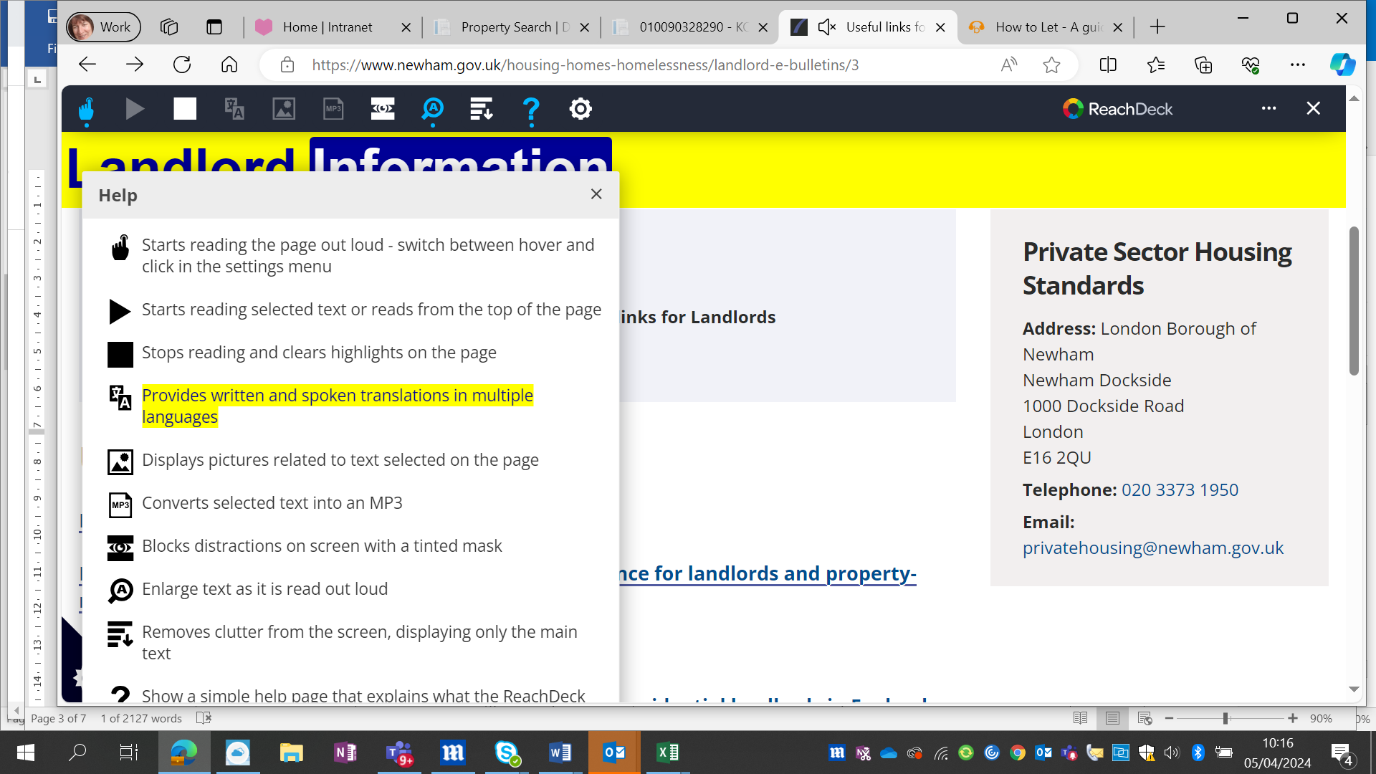 | Yes  Yes
4.To integrate initiatives using the framework of property licensing to target fuel poverty and climate emergency/carbon reduction and security measures across Newham’s private rented housing sector | - Using property-licensing data to help identify the least energy efficient homes as part of the Council’s fuel poverty strategy and Climate Emergency response.  - Ensuring that audit checks on these properties and any required enforcement action for non-compliance; are equally prioritised, alongside using other enforcement tools outside of licensing, for example Minimum Energy Efficiency regulations and Part 1 Housing Act 2004 to achieve this objective.  - Signposting eligible landlords and tenants to the Green Home Grants scheme and other ECO funding to secure retro-fitting that will enable energy efficiency and warmer homes.  - Providing an incentivising discounted licensing fee for those PRS homes that meet an EPC rating/band of C or above, and also those that have high standards of security | - Landlords are signposted to grant opportunities under the Government’s ECO4 scheme@ https://www.newham.gov.uk/public-health-safety/energy/14  - The scheme supports landlords to improve the insulation of their rental properties. Discount of £50 for warm homes EPC or better.  - 76 cold homes (EPC F&G) were subject to enforcement.  - 100 families were assisted through the Green Doctors scheme, a charity that provides energy advice.  - 147 Newham households were supported through the Seasonal Health Intervention Network (SHINE), which is a fuel poverty referral network and free energy advice service for Londoners.  - 351 applications for the Sustainable Warmth scheme. The scheme provides £10,000 worth of work for homeowners, and private renters with EPC D or lower and low-income residents.  - 533 applications to Mayor of London’s Warmer Homes Scheme. The scheme provides £10,000 worth of work for homeowners and private renters with EPC D or lower, and low income residents | Yes
5.To support all private tenants in Newham and ensure that they are secure and safe in their homes including working with private tenant organisations | - Setting up regular PRS tenant forums and enhancing the Council’s Renters Rights Hub  - Establish a Newham Renters Rights and PRS Forum chaired by the Mayor of Newham and including the Cabinet lead for Housing Services, independent experts and key PRS tenant rights organisations to identify and address systemic issues in Newham’s PRS; support the ongoing effectiveness of the Council’s landlord licensing scheme, and to refer cases of poor property disrepair or mismanagement by landlords and their letting management representatives | - Bi-monthly PRS catch-up with Newham representatives for Shelter, Magpie and London Renters Union. Complaints via members are referred on and discussions held on PSH policy topics. Examples include property licensing, disrepair, damp & mould strategy, lettings policy, temporary accommodation policy, homelessness approach and support for vulnerable groups such as single parents and asylum seekers.  - Two tenants forums were held on 18 June 2024 and 26 November 2024. Attendance from private rented sector (PRS) tenants at these dedicated forums was low. To improve engagement, the service has adopted a more targeted approach, including monthly engagement sessions with the London Renters Union/Magpie and Shelter to raise issues affecting PRS tenants and discuss Private Sector Housing and homelessness policy and legislative changes. An updated Renters' Rights Act (RRA) campaign, supported by revised FAQs on the Council website, has also been developed to assist PRS tenants. Further engagement activities have included a meeting with a SEND parents group in April 2026 and the use of TikTok awareness campaigns to broaden outreach and increase engagement with residents.  - Approximately 200 front line officers/volunteers attended PSH presentation on spotting and referring on housing disrepair in PRS properties at social welfare alliance training sessions. | Yes
6.To further develop a range of initiatives and tools to support private tenants and landlord across the private rented sector, | - Partnership working with the Council Community Safety Enforcement Service to continue a responsive out-of-hours service targeting Newham’s PRS, to tackle on-going noise and antisocial behaviour impacting on residents, and ensure landlords address such issues.  - Developing and investing in more efficient software/data tools for the administration, monitoring and tracking of those residential properties subject to the selective and additional HMO licensing schemes.  - Increase the provision of Tenancy Liaison officer roles, mediation and legal support to tenants and landlords where there is a tenancy dispute as part of the Council’s Tenant Rights Hub offer. | Regular liaison with ASB team and set out in a Service level agreement to support the out of hours service, use of landlord licensing conditions to best manage antisocial neighbourhood ongoing issues such as loud amplified music, disturbance from large gatherings, management of rubbish and correct refuse collection in front gardens.  - 4,284 letters sent out to perpetrators and landlords concerning noise and ASB matters in licensed property (January 2023 to March 2025).  Inclusion of nightly let temporary accommodation (NLTA) within the third licensing scheme and support provided to Temporary Accommodation team to undertake compliance inspections and audits to ensure minimum accommodation standards and safety certificate requirements are met.  - 1,157 (NLTA) Newham properties now have valid licences and safety checks.  - 797 in-borough compliance inspections from a total of 1,159 (2023-26)  - Upgrade to data management system to provide an online comprehensive licensing application form and payment platform. Phase 1 and 2 improvements completed in May and December 2023. Phase 3 upgrades to be completed in 2025.  - Two Tenancy Liaison officer roles within PSH are now permanent posts. 1,926 referrals made since roles started in 2022 and after investigation, over 200 evictions avoided. Regular liaison with the Homeless Person Assistance Service to sustain tenancies where possible and raise awareness on tenants’ rights etc. | Yes  Yes
7.To ensure that all residential letting agents in Newham are fully compliant with consumer protection and rights legislation | - Investigating all operational letting agents over the lifetime of the schemes and taking enforcement action where consumer law has been breached.  - The intention of the Council is to achieve the investigation of 100% of letting agencies throughout the lifetime of the scheme, but this is challenging in a sector with high rates of company dissolution. | - All letting agents of concern were inspected. As a result  125 final financial penalty notices served on Letting Agents, which were non-compliant. The key areas of non-compliance were for consumer rights (68) and client protection (57) law. | Yes
8.To continue to share good practices with stakeholders and Government, particularly in respect of data sharing and operational activities, in the regulation of private rented homes | - Reporting performance and enforcement activity under the licensing schemes via monthly dashboard updates on the Council’s website (supported by effective communications and marketing output); alongside quarterly reports presented to the Newham Renters Rights and PRS Forum, Landlord Forum, and the Cabinet; and an annual report during the lifetime of the schemes.  - Working with other local authorities, GLA, PRS sector partners and interest groups, and government to share good practice and highlight systemic issues requiring improvements to the regulation of the private rented sector.  - Undertaking campaigning and advocacy activities to lobby for any legislative changes required to protect renters’ rights in the PRS; supported by effective communications, marketing and lobbying campaigns as well as research and evaluation activities. | - Monthly reporting against KPIs circulated internally.  - Quarterly reporting highlights provided on our webpages here Performance Summary – Landlord Resources – Newham Council  - Annual report after 1 year of operation of the two property licensing schemes Microsoft Word - PSH Property Licensing Third scheme 2023-28 AO 7 EP Cladding Year1 performance summary April24 web.  - Annual report after 2 years of operation 2024-2025 updated here: Microsoft Word - PSH Licensing Scheme 2023-28 Year2 Performance Summary  Working with others:  - Presentations to Southampton CC and LB Haringey scrutiny committees on LBN property licensing schemes alongside cabinet lead members. Good licensing practice & designation advice presentations to CIEH, ALEHM, LB Lewisham and Brighton CC.  - Regular monthly engagement with LB Waltham Forest, Enfield, Redbridge & Ealing on operational issues for large scale property licensing  - Monthly engagement with GLA on property licensing issues and sharing good practice with private sector housing managers across London.  - Presentations at Association of London Environmental Health Managers (ALEHM) and with MHCLG on sharing good practice for property licensing schemes.  Campaigns  - Centre for London think tank – main sponsor for London wide published report Licence to let on potential of selective property licensing to improve conditions in London’s private rented sector and recommendations for the governments property portal proposals under Renters Reform Bill. (Nov 2023)  - Renters Reform Bill and Decent Homes Standard- submissions on government consultation.(Sept 2024) https://www.gov.uk/government/news/measures-to-ensure-decent-homes-for-all  - How to improve living standards for millions of private renters in England and Wales design for a fair and effective enforcement strategy by independent think tank E3G, James Dyson (March 2025) – participation by LB Newham and a case study used in report @ https://www.e3g.org/wp-content/uploads/E3G-Briefing-Improving-living-standards-private-renters-England-Wales.pdf  - Responded to Supported living licensing government proposals-April 2025-https://altairltd.co.uk/2025/03/18/supported-housing-regulatory-oversight-act-2025-consultation/  - Mandatory HMO licensing- 2 year exemption proposal- government drops proposal to exempt asylum seeker accommodation for 2 year period after human rights challenge case after human rights challenge case which Newham supported along with CIEH as an expert witness outlining asylum seeker hotel experiences.  - LB Newham Charge safe LB Newham Charge safe - E-bike/e-scooter battery, fire safety campaign, with LFB and Newham Community Project 9 NCP) 2023-2025. Following a large increase in 2023 in serious fire incidents in overcrowded HMOs. The focus was to raise awareness with international students resident in LB Newham, many who work as couriers using e-bikes in the gig economy to safely charge and store e-bike batteries. Local NCP Ambassadors were trained to engage at grass roots level to raise awareness of fire safety concerns with couriers. Report and recommendations will be launched at UEL and published on LBN website in summer 2025.  - Overcrowding Research governance group set up in 2022-2024 and commissioned LSE to undertake survey and interviews and research for overcrowding in the private rented sector and what was the best support that LAs could offer. Report @ https://sticerd.lse.ac.uk/dps/case/cr/casereport156.pdf  National Awards:  - Local Government Chronicle (LGC) Awards 2024 finalist for  Best Housing Team for Private Sector Housing property Licensing scheme  - 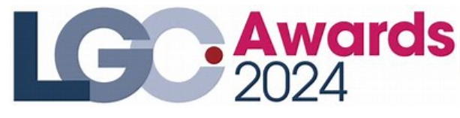  - UK Housing Awards 2024- finalist for best LA housing initiative November 2025 for Private Sector Housing property Licensing scheme  -  | Yes  Yes  Yes  Yes  Yes  Yes

