

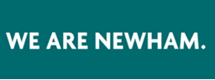


Easy Read Reward and Recognition Guidance for Co-Production and Engagement - Adults and Health
We Value
Working Together

What is Reward and Recognition?

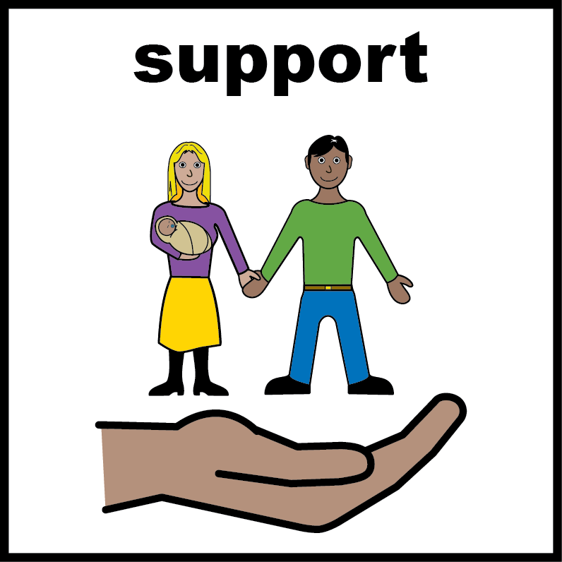 | Lots of people in Newham use adult social care services.
 | We want people who use our service to tell us what they like or don’t like.
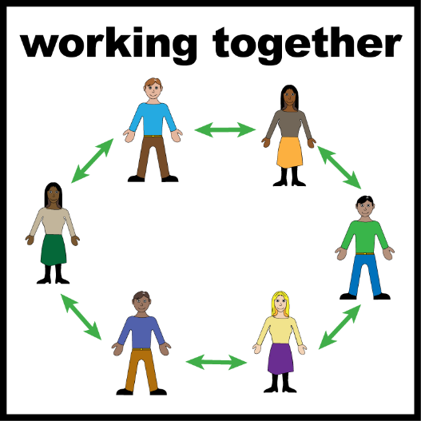 | We can work together to make our services better.
 | We want to say thank you when people help us.
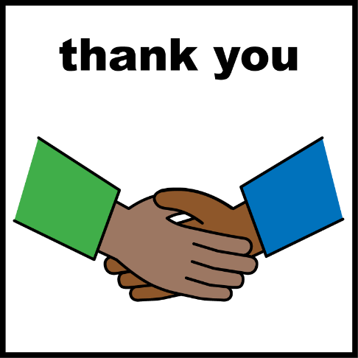 | Sometimes this means we can give people money or a voucher. This is called Reward and Recognition.

What is the Reward and Recognition guidance?

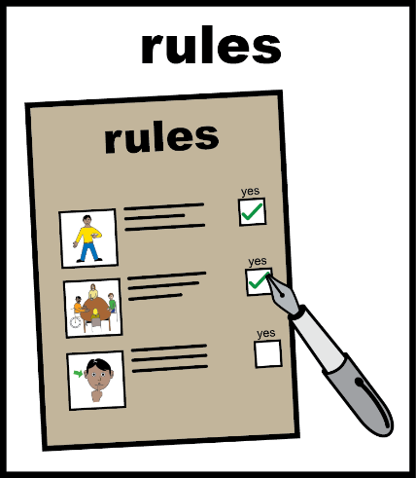 | It is a set of rules about how and when we can give people money or vouchers when they help us.
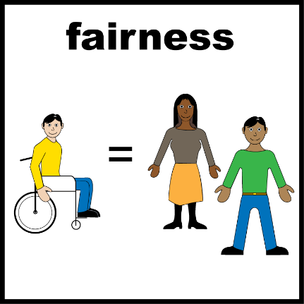 | It means we can be fair to everyone.

Why do we want people to be involved?

 | We want to know what people think.
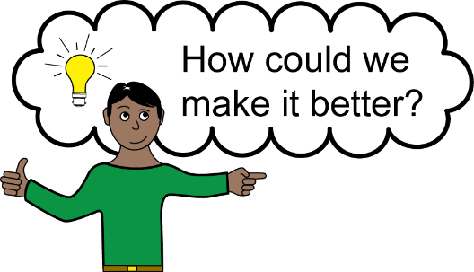 | It means we can change the right things.

Reward and Recognition for different involvement roles

We can’t usually pay people for helping us through consultation or public involvement, for example

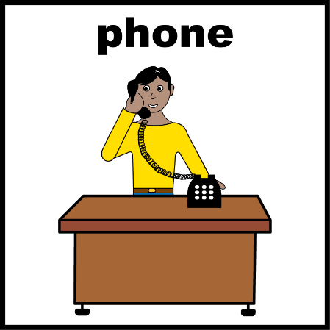 | - When you answer questions in a survey
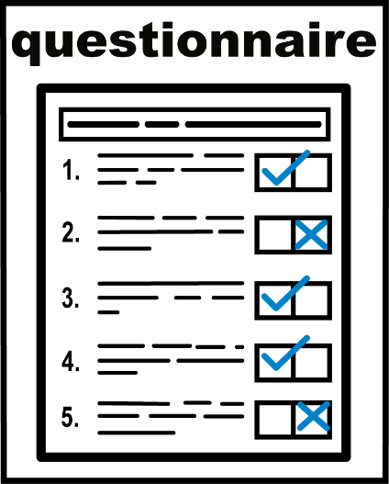 | - When you answer questions in a survey or questionnaire
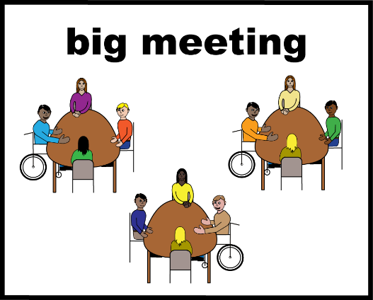 | - If you take part in these activities, we usually can’t pay you
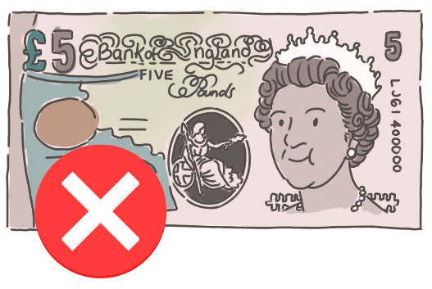 | If you take part in these activities, we usually can’t pay you

Reward and Recognition for co-production

 | We can sometimes pay you for co-design and co-production
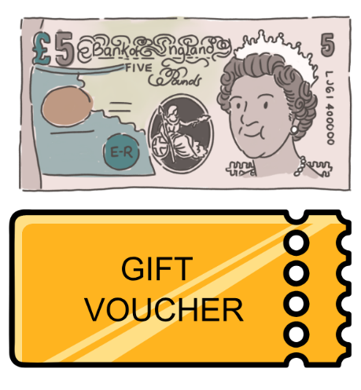 | We call some things co-design and co-production.  We can sometimes pay you or give you a gift voucher.
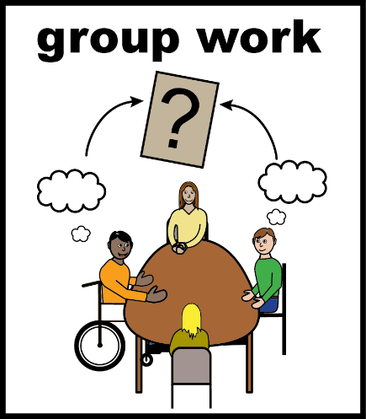 | These activities include:  - Being part of a working group. Working groups are people who work together to design things like services or policies.
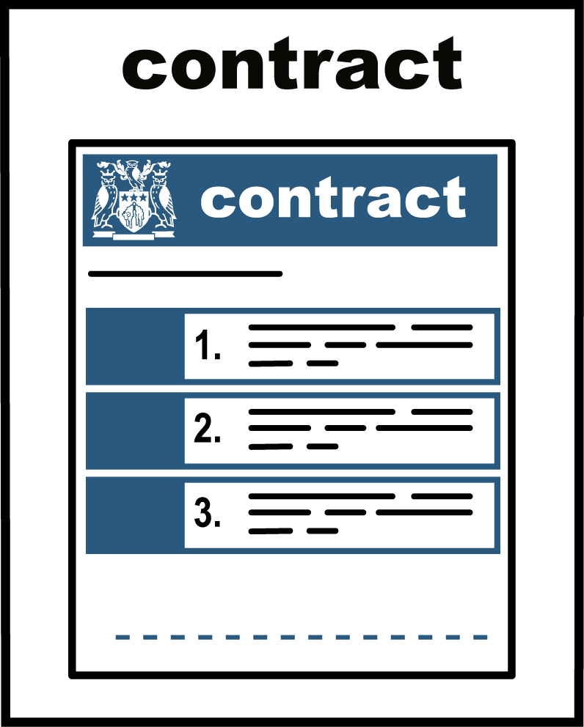 | - Helping us with procurement. This is when we decide which organisation we want to buy services from.
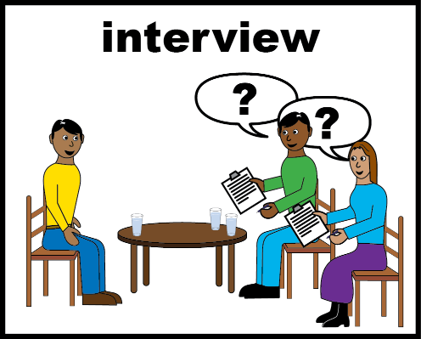 | - Joining an interview panel to interview people for a job in Newham Council.
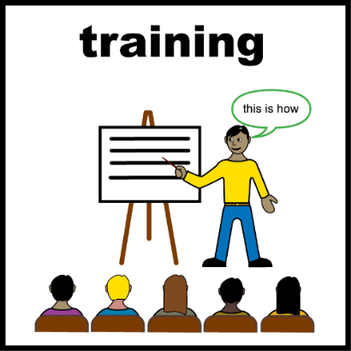 | - Training people about something you know about or have experience of.
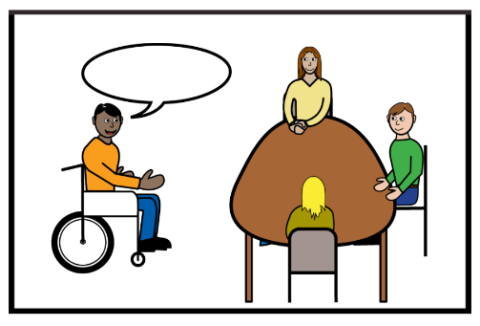 | - Helping us deliver workshops or other group activities.

How we normally pay you

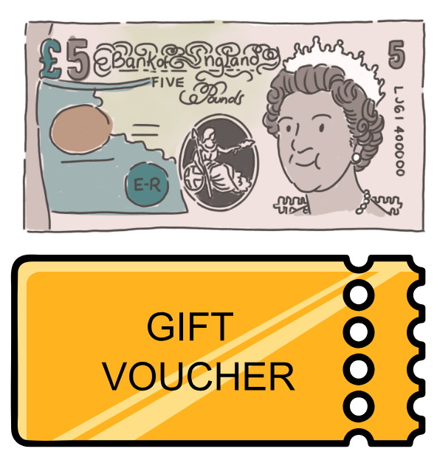 | Payments will be made by bank transfer or shopping voucher.
 | Payments are £15 per hour from June 2026.
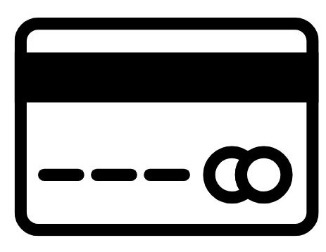 | If you would like to be paid by bank transfer, then you will need to write your bank details on your claim form.  This includes your sort code and account number.  Do not write down the long card number or security code on the back.
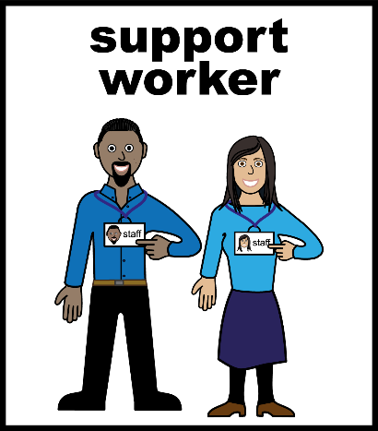 | If you need support to do this, please speak to your support worker or a member of the Co-Production Team.
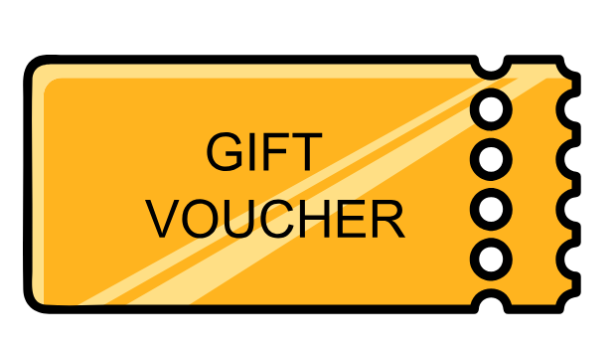 | We can also be paid your Reward and Recognition using a shopping voucher.  We can send these to you by post or by email.
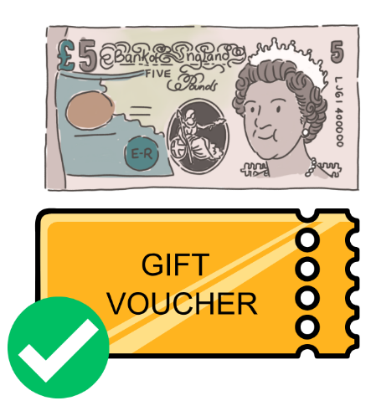 | You have a choice about how you are paid  - You can ask to receive a full payment
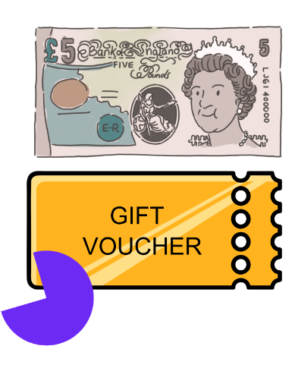 | - You can ask for a partial payment.  This means you do not want the full amount.  Sometimes people want this for reasons to do with their benefits. You can ask a staff member about this.
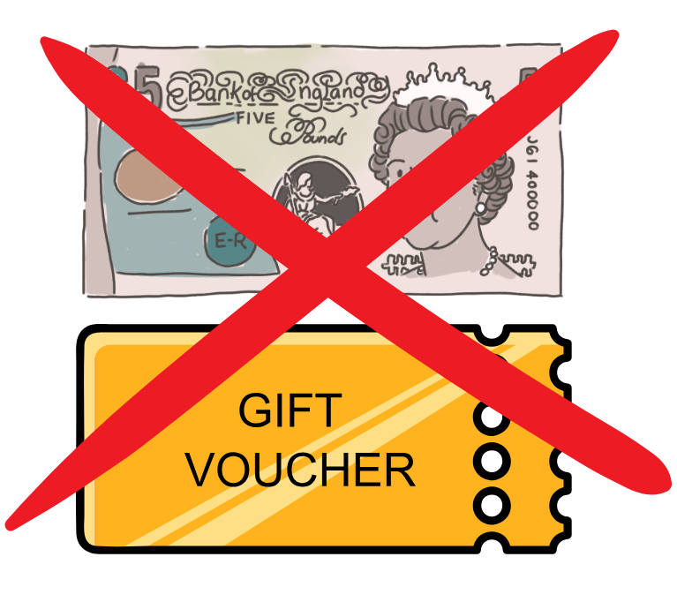 | You don’t have to be paid if you don’t want to. This is called voluntary participation.
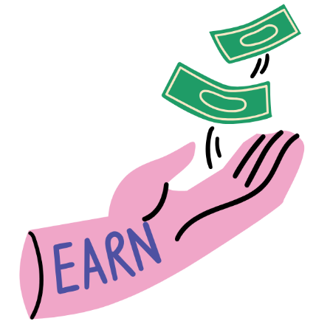 | If we pay you, it does not mean you are an employee.

Your rights and responsibilities

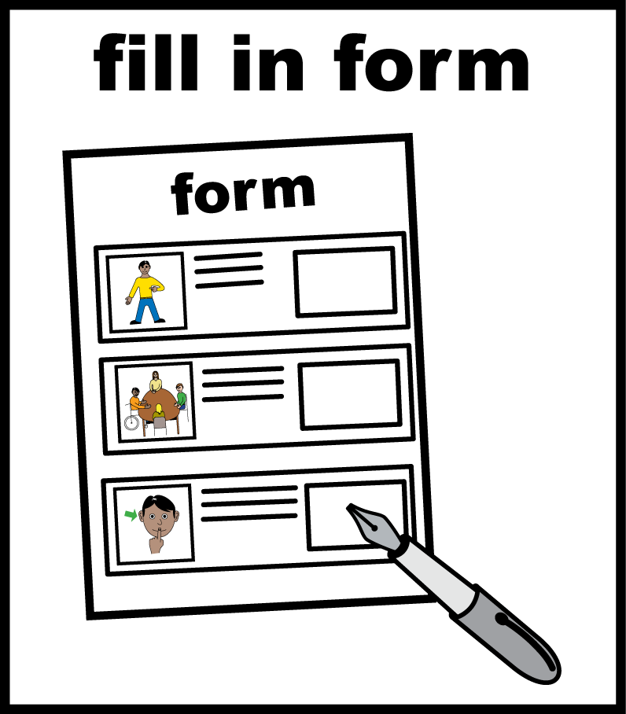 | You are responsible for:  - Filling in any forms and returning them within a month
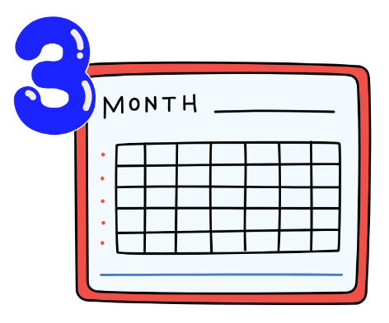 | You should send your claim form to the Co-Production Team within 3 months of the activity. If you send your claim after 3 months, it may not be accepted.  We may make an exception if you have an important reason, such as being in hospital, which stopped you from sending your claim on time.
 | - Speaking to the Jobcentre Plus or your benefit office about any potential impact on your benefits. Or getting support from your support worker to do that.  If you get benefits and choose to accept a Reward and Recognition payment, this might affect your benefits.
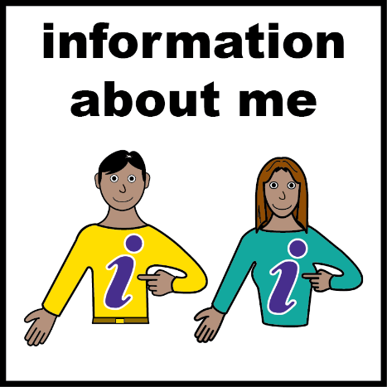 | - Updating your information. Let us know about any changes to your situation e.g. your bank details or your address
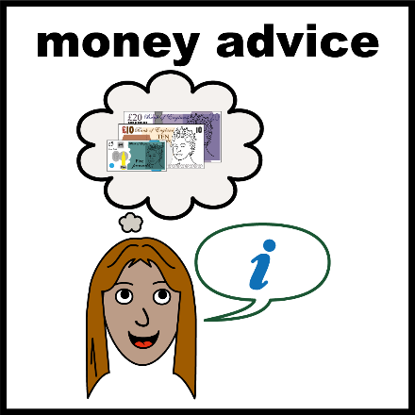 | - Get expert advice on your financial situation and the possible impact on benefit or taxes  Payments can also be liable for tax and national insurance.
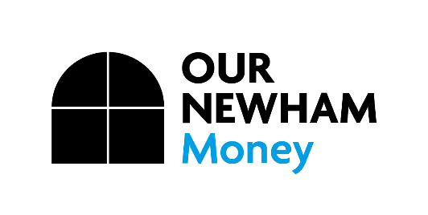 | You can speak to Our Newham Money for expert advice on  020 8430 2041  Open Monday – Friday 9am to 5pm
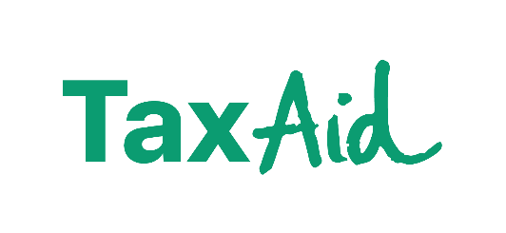 | You can also speak to Tax Aid for expert advice  0345 120 3779  Our helpline is open Monday – Friday  9am to 5pm.  www.taxaid.org.uk/

Our responsibilities

 | We will tell you if you can claim Reward and Recognition for an activity, how much it is, and how you’ll receive it.
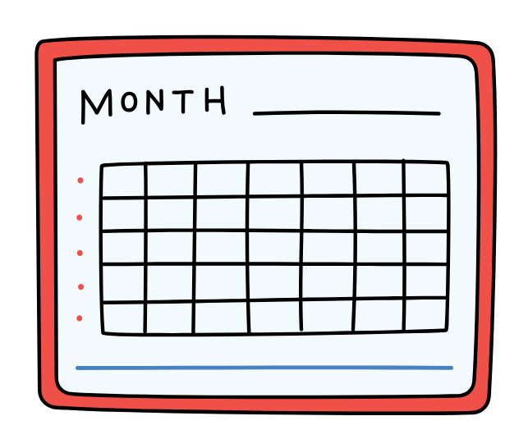 | We will process your claim form in a timely manner, usually within one month.
 | If you need any support or have any questions, then please contact the Co-Production Team.

Expense payments

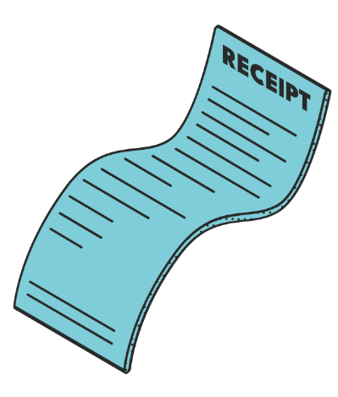 | Newham Council may be able to pay for costs related to your involvement.  These need to be agreed with the Lead Officer before the activity.  What this might cover:
 | Travel costs. This may include:  - Public transport e.g. bus, underground  - Parking or petrol costs (if you drive your own car)  - Taxis (if public transport is not suitable because of your health or disability.
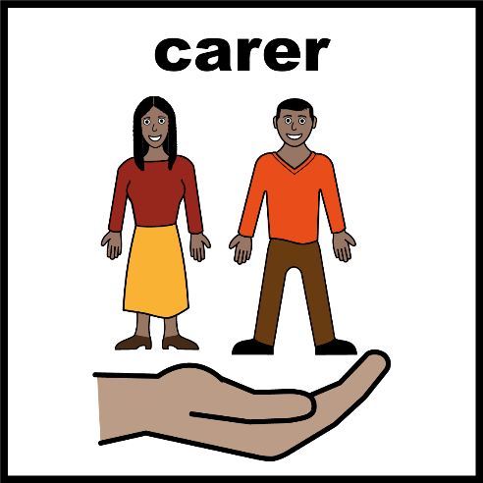 | Care costs  If you need help from a personal assistant or carer to take part, and this can’t be covered in your care hours, then we may be able to pay for this too.
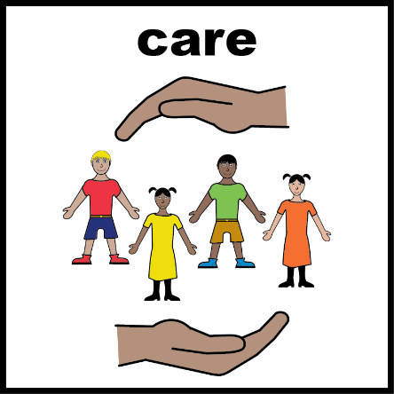 | Child care  If you need childcare support, outside of school or normal care hours, then we may be able to pay for this.  For childcare over two hours, the carer needs to be a registered carer.
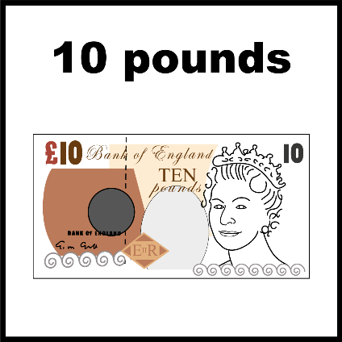 | Expenses do not affect benefits.  Your expenses can be separated from your Reward and Recognition payments.

Contact Us

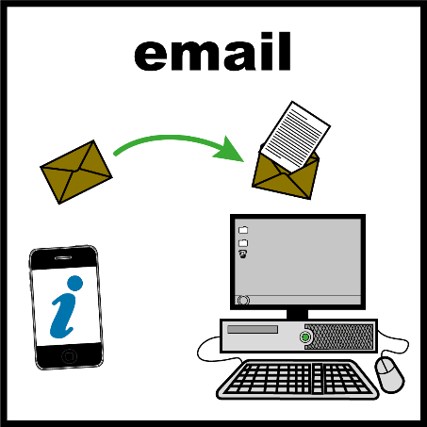 | If you have any questions, then please speak to the Co-Production Team at:  Email: Co-productionteam@newham.gov.uk
 | Phone: 07970 406 126
Thank you to our colleague at Hackney Council for share the Easy Read of their Reward and Recognition Policy to shape the Easy Read copy of our Guidance.

