

Independent Reviewing Officer (IRO) Service Annual Report 2025/26

WE ARE NEWHAM.

newham.gov.uk

Table of Contents
1. Executive Summary 3
2. Introduction 3
3. Professional Profile of the IRO Service 4

4. Data on Children in Care 4

5. Data on IRO Service 14
6. Quality Assurance 16

7. Learning from Complaints 19

8. Compliments 19

9. Priorities for 2026/27 19

10. Independent Reviewing Officer Service Action Plan – 2026/27 20

1. Executive Summary

This annual report provides an overview of the operation of the Independent Reviewing Officer (IRO) Service in 2025/26.
This report includes information on the impact of the IRO Service on its work with children and families in the London Borough of Newham.
This annual report has been produced by the Quality Assurance Service in line with statutory guidance.
This report captures the activity and progress of the IRO service with a specific focus on the last 12 months and sets out our priorities for 2026/27.
The body of the report sets out the key demographics of Newham’s children in care population along with legal status, type of accommodation and geographical location.
Practice data is provided with commentary with a specific focus on the following key indicators:
- Timeliness of child in care (CIC) reviews with a target at 97% per month
- Participation of children and young people in reviews with a target of 97% of reviews evidencing child contribution to care plan
- Evidence of increased IRO ‘footprint’ via Midway Monitoring and continued evidence of use of formal IRO dispute resolution process
- Findings from thematic QA activity and the impact of IRO intervention on outcomes for children
- Forward planning to increase parent, carer, professional feedback
The report also highlights areas of practice concerns that are impacting on the outcomes of children and has sought remedial actions when required.
Jacqueline Addinall, Service Manager, Independent Reviewing Officer Service

2. Introduction

2.1 The Independent Review Officers’ (IRO) service is set within the framework of the IRO Handbook and is linked to revised Care Planning Regulations and Guidance (April 2011). The responsibility of the IRO changed from management of the Review process to a wider overview of the child, to include regular monitoring and follow-up between Reviews. The IRO was seen as having a key role in relation to the improvement of care planning for children in care and challenging any drift and delay of their care planning.
2.2 The National Children’s Bureau (NCB) research ‘The Role of the Independent Reviewing Officers in England’ (March 2014) provided both information about and findings regarding the efficacy of IRO services. The foreword written by Mr Justice Peter Jackson makes the following comment:
“The Independent Reviewing Officer must be the visible embodiment of our commitment to meet our legal obligations to this special group of children. The health and effectiveness of the IRO service is a direct reflection of whether we are meeting that commitment, or whether we are failing.”
2.3 Throughout 2025/26 the IRO Service has continued to draw on the expertise of neighbouring London IRO services via the North East London IRO partnership with CAFCASS and the London IRO regional group of the managers group known as NIROMP. The report outlines ways in which the IRO Service achieved its outcomes in 2025/26 and what is envisaged in the year ahead.

3. Professional Profile of the IRO Service

- IRO Posts 6.5 FTE, (9 individuals)
- Gender – 8 Females / 1 Male
- Ethnicity – 6 of the staff are from a Black and Global Majority background
- Experience – All staff have over 10 years of social work experience.

4. Data on Children in Care

4.1 Number and rates of Children in Care

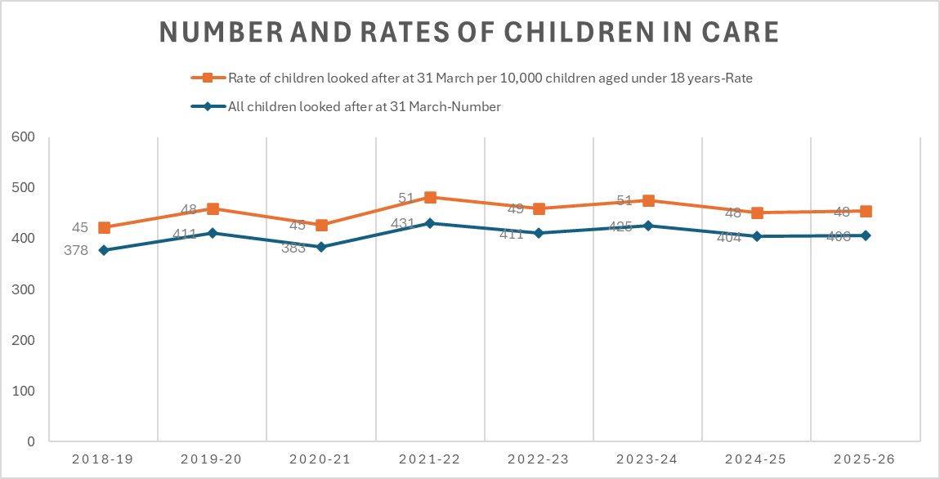
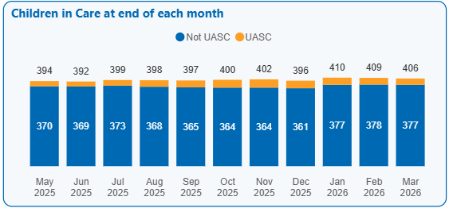
Table 1a – Children in care (CIC) numbers;
On 31st March 2026 there were 406 children in care.
4.1.1 The increase in the number of children from the latter part of 2021/22 to over 430 children in care reduced in 2024/25 following investment into an edge of care service which aims to support children to remain in their families or kinship systems. The service also supports children to return to their families. At 31st March 2026 the number of children in care (406) was consistent with last year (404 at 31st March 2025). The IRO caseload has remained in line with the IRO Handbook regulations of between 50 and 70 children per Full Time Equivalent staff member with an average caseload of 62.
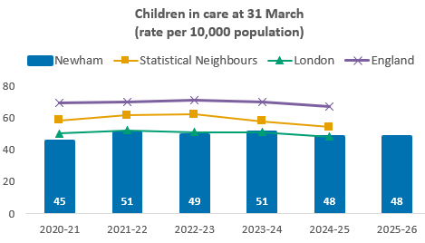
For benchmarking charts: Statistical Neighbours (SN) reflect the DfE comparator groupings released in May 2025. Newham’s statistical Neighbours are: Brent; Barking and Dagenham; Enfield; Leicester; Haringey; Luton; Ealing; Hounslow; Manchester; Slough.
Benchmarking data source: Data to Insight Children’s Social Care Benchmarking Tool v4.08 and LAC 903 Statistics Prediction tool v2.2026g https://www.datatoinsight.org/tools
Table 1b - CIC rate per 10,000; snapshot at period end
4.1.2 Benchmarking data has historically placed Newham’s rate of children in care per 10,000 populations under 18 below rates reported for our statistical neighbour’s average of 54, and the same as the London average of 48 per 10,000.
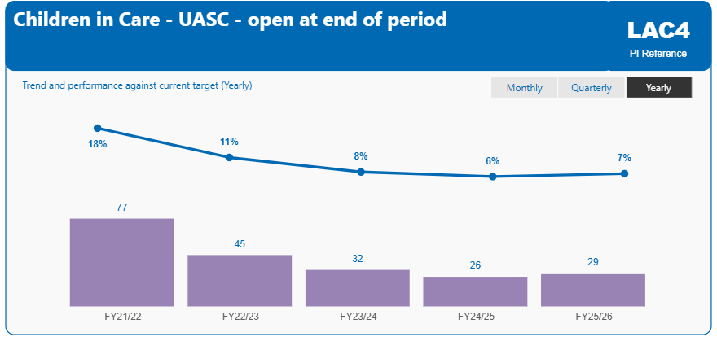
Table 1c - CIC numbers; UASC at period end
4.1.3 29 children in care (7.1%) were unaccompanied asylum-seeking children (UASC). The profile of children entering care has changed with more local adolescents entering our care with complex needs and fewer unaccompanied asylum-seeking children. However, with the UASC cohort there has been increased challenges due to complexity with age assessments and judicial reviews.
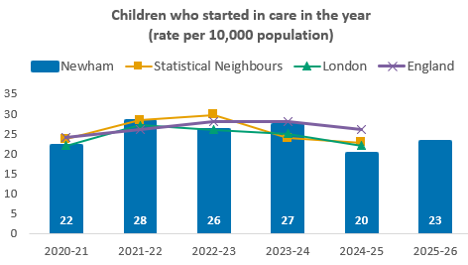
DfE method for counting starts is based on unique children. For example, if a child started in care, left care and then restarted in care during the year, they would be counted once.
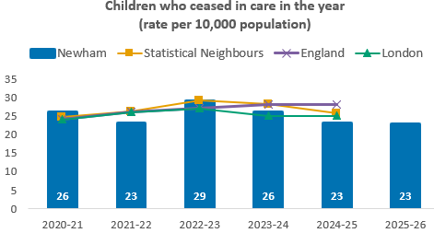
Children are only counted as ceasing in care if they did not subsequently re-enter care in the year.
Tables 1d - Children starting/ ceasing in care during 2024/25
4.1.4 The number of children starting in care in 2025/26 (193 individual children) was similar to the number leaving care (191 individual children) with both rates similar to previous years.
4.1.5 The proportion of children accommodated under Section 20 during 2025/26 was 33.87%. 188 out of a total 555 children in care during the year
4.2 Profile of Children in Care – Importance to the IRO Service
Nationally it has been noted the profile of children in care by a Local Authority will shape the IRO Service both in terms of expertise required and focus. It should also inform the training and development priorities as well as the work plan.
4.3 Gender and age
Of the 404 children in care on 31st March 2026, 226 were male and 177 female (based on gender at birth). This large disparity is in part accounted for by the predominance of males in the UASC cohort and to a lesser extent the children who became a child in care by virtue of being remanded.
Table 2a - Gender of CiC – 31ST March 2026
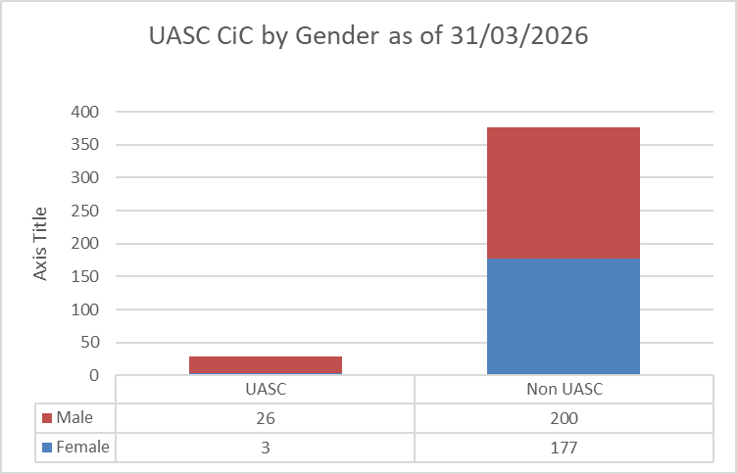
While gender disparity is seen across all age bands, it is most prominent for children aged in the 16-17 age group who are UASC as well as late entrants into care. There has however been year on year increase in the numbers of local teenage girls entering care. This is outlined in the 3 tables that follow:
Table 2b - Breakdown by Age group: Number of open CIC cases at period end: (903)

Table 2c - Age when came into care; for all episodes of care starting in year 2024/25
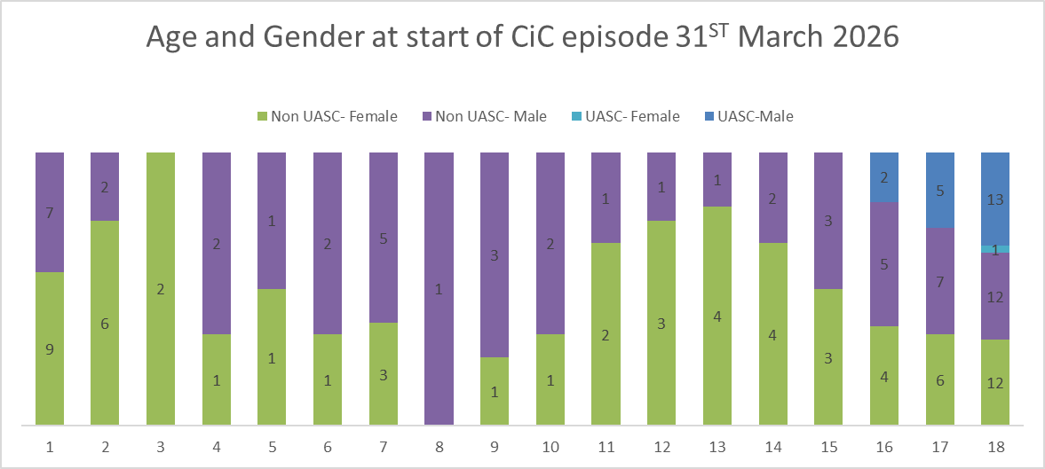
Table 2d - Age of Children in Care cohort: for CiC at period end
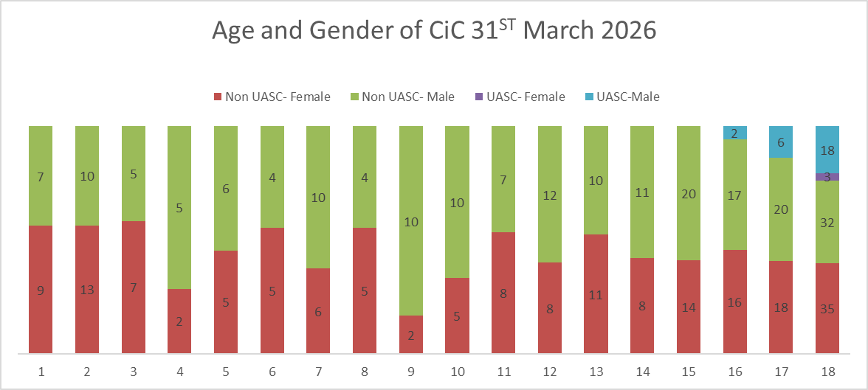
4.4 Ethnicity of Children in Care

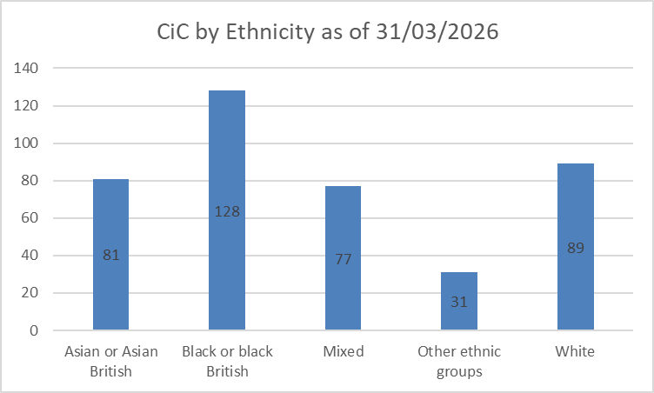
Table 3a - Ethnicity of CIC; Broad DFE groups: at period end (903)
4.4.1 The Children in Care cohort is ethnically diverse, with Black or Black British children (128) representing the largest group, followed by White (89), Asian (81), and Mixed (77) children, and a smaller number from other ethnic groups (31). Overall, children from Black and Global Majority backgrounds make up a majority of the cohort, requiring ongoing monitoring and assurance that care planning is equitable and culturally responsive. The dataset shows Black and Global Majority groups are over-represented in figures across the child’s journey including within children in care population - children of Mixed heritage are proportionality significantly over-represented relative to the children’s population in Newham, followed by Black and Other, with Asian or Asian British children being under-represented.
4.4.2 The Newham Safeguarding Children Partnership (NSCP) has made tackling racism, inequality and disproportionality (TRID) a priority and this is reflected in the work on children in care in Newham’s Children’s Services. Progress has been made in developing a comprehensive disproportionality dataset across the child’s journey which is scrutinised at the monthly Practice and Outcomes Board and CYPS TRID Working Group.

4.5 Legal Status for Children in Care
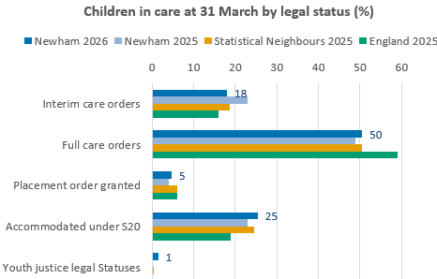
Table 4a - Legal status of CIC; at period end (903)
4.5.1 The above table shows the increase in children subject to Care Orders. The proportion of children on Full Care orders increased slightly to 50% indicating that proceedings are concluding in a more timely manner with the reduction of the proportion of children still subject to Interim Care Orders.
4.6 Other factors - Disability
4.6.1 12.4% of children in care are recorded as having a disability. This includes 25 children held by Disabled Children and Young People’s Service. Again, this is in line with previous year and compares well to Newham’s disabled children’s population at 13%. It should be noted there is a smaller number of children where disability is recorded as being the primary reason for their care, indicating the improved support available to families who are caring for a child with a disability.
4.7 Placement Type

4.7.1 The types of placements for children in care at 31 March 2026 were broadly consistent with last year.
4.7.2 36.5% of children in a fostering placement at 31 March 2026, were recorded as in a long-term matched placement, with 44% long-term matched in our in house foster placements. Work undertaken in the Permanency Tracking Panel is continuing to improve these figures.
4.7.3 33 children were placed in residential care at 31 March 2026. This is a small increase from 32 at the end of March 2025. We previously saw an increase in adolescents with very complex needs and a requirement to provide specific packages of support for them combined with placement sufficiency issues. Work has been undertaken by services, including the Edge of Care Service to find alternative and safe options for these children to step out of these types of provisions where possible and the with targeted intervention to move children to specialist foster placements.
4.7.4 As part of the Local Authority’s tracking of such moves the IRO Service Manager continues to ensure the IRO’s understanding of the of child’s story in care is shared with the Senior Leadership Team Placement Review Board. This includes details of children’s views, the permanency plan endorsed, informal and formal disputes as well as impact of social worker turnover. The IRO views of all placement and support requests are also shared with the Access to Care and Resources Panel and the Youth Justice Service Panel where appropriate. This has led to understanding the importance of confirming semi-independent placements as the long-term plan for children over 16 and challenging when required the limitations of group care to deliver permanency for children of all ages.

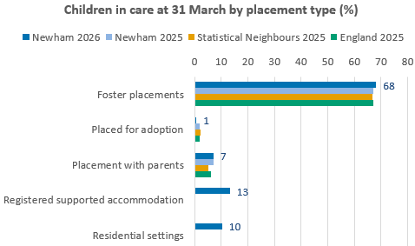
For the first time the DfE has split placement data between Supported accommodation and Residential settings (e.g. Children’s homes), although benchmarking data is not yet available for this split.
Table 5a - Placement type as at period end
4.8 Placement Stability
4.8.1 At the end of March 2026, 71% of children who had been in care for 2.5 years had been in the same placement for at least 2 years – an improvement on previous year, which was 68% at the end of March 2025. The proportion of children in care who had been in care for more than 2.5 years steadily increased during the year. This may be due to a reduction in the number of children entering care due to the impact of the edge of care service. The data shows a general improvement in placement stability over the past six years. Analysis of age breakdown highlights persistent challenges in maintaining stability for adolescents. While there has been significant progress for the youngest age group (0–4), where instability halved, older cohorts, particularly those aged 11–17, continue to experience higher rates of disruption. These findings reinforce the need for more tailored support and placement options for older children and those with complex needs.
4.8.2 The proportion of children with three or more placement moves has improved from 14% in 2019/20 to 10% in 2025/26. This reduction suggests progress has been achieved in supporting more stable placements. Our analysis shows that that the earlier a child comes into care, the more likely it is that they will experience long term placement stability. Children who have come into care aged 11-13 are the least likely to experience long term placement stability. This insight correlates with our experience and reasons for this are likely to include:
- Older children being more likely to have experienced chronic neglect and abuse and therefore presenting with higher levels of trauma
- Older children struggling to form new attachment relationships when coming into care
- Older children being more likely to come into care for reasons such as being beyond parental control, exploitation and extra-familial harm.

Children presenting with the above types of needs are very difficult to find foster placements for, meaning that they are much more likely to be placed in residential care. The Local Authority will usually want to find a foster placement for these children, meaning that residential is very rarely an agreed long-term plan. Furthermore, children with the most complex needs living in residential care are likely to have the most moves. As of 31/03/2026 the group of children with the most placement moves were Black – African and 8 children who had been in care for 12 months or more and had 3 or more placements within the previous 12 months.

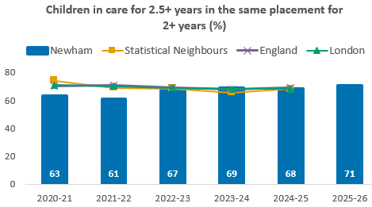
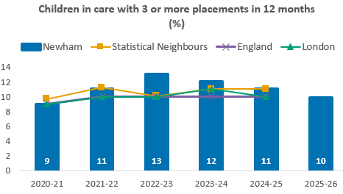
4.9 Placement Location
Table 6a - Placement location: at period end (903)
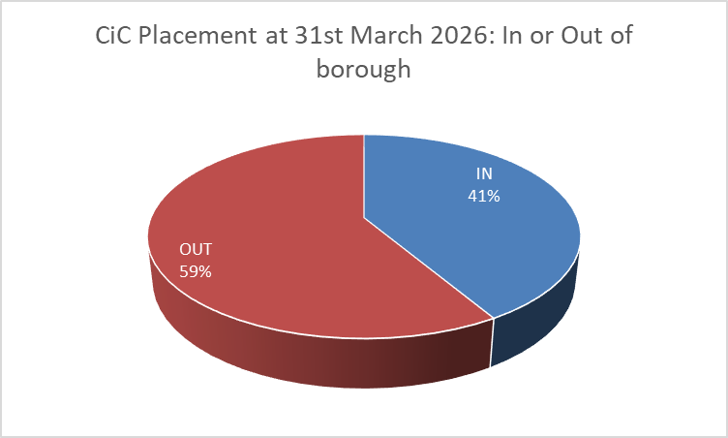
4.9.1 The majority of Newham children in care reside outside the borough (a pattern shared with many inner-city London Boroughs). 89% however are placed within 20 miles of Newham in neighbouring Local Authorities.
Placement Distance | Total Children | %
CiC placed more than 20 miles | 44 | 11%
CiC placed under 20 miles | 362 | 89%
Total | 406

4.9.2 An exception is the small use of some children homes some distance from the local authority for children with significant safeguarding concerns because of child exploitation. The role such arrangements can play has been the subject of IRO group supervision and has been highlighted as a theme in informal and formal disputes as has been the use of children homes in the rare instances for children under the age of 12.
4.10 Outcomes for children in care
4.10.1 Outcomes for children in care’s education Early Years, Phonics, Key Stage One and Key Stage Two have been consistently above the national average for children in care. For the eligible cohort who completed their KS2 in July 2024 42.3% reached Age Related Expected levels in Reading, Writing and Maths according to centre assessments (last available national average was 34% in 2024). Similarly, outcomes at Key Stage 4 have been above the national average for some years. In the most recent statistical release Attainment 8 is 29.6 in comparison with the national average of 23.3.
4.10.2 The health assessment completion rate for children in care for 12 months or longer improved to 87% in 2025/26 (from to 81% in 24/25).
4.10.3 75% of children in care for 12 months or longer were reported as having their immunisations up to date, up from 71% in 2024/25. Work is underway by East London Foundation Trust colleagues to review data available via other health systems, checking the immunisation status based on both the childhood and school vaccination programmes.
4.11 Reason for Ceasing to be a Child in Care
4.11.1 The proportion of children returning home has been a focus of the Service including the Edge of Care service who in 2025/26 supported with 39 children reunify home (but 36 separate children as 3 came back into care and returned home again). This is a huge increase of almost 3 times as many children as the previous year.

4.12 Missing Episodes and Duration

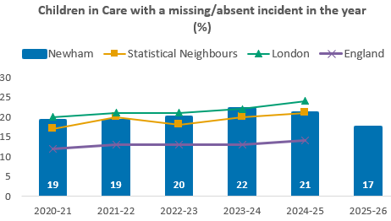
4.12.1 Whilst the overall number of missing incidents in 2025/26 rose compared to last year (1,656 incidents compared to 1,481 last year), the unique count of individual children who went missing from placement on at least one occasion in the year fell. 102 children had one or more missing incident in the year, equating to 17% of children in care in the year. This was down from 123 individual children last year (21% of children in care).
4.12.2 Over the past year the IRO Service has continued to focus on ensuring the findings of the Return Home Interviews inform the outcomes of children’s reviews. The IROs have increasingly ensured the workers conducting Return Home Interviews are included in children’s reviews as one of the ways to support participation in what is their meeting. This has included being satisfied the Local Authority has followed relevant procedures and that ensuring plans arising from strategy meetings are robust and are based on clear analysis of the push/ pull factors in the child’s life that may be contributing to missing episodes.
4.12.3 This focus on ensuring each missing episode is understood and used in developing the relevant plans for children has been significantly assisted by continued inclusion of the allocated IROs in receiving the daily missing children list providing more consistent oversight of missing episodes.

5. Data on IRO Service

5.1 Timeliness of Reviews
5.1.1 During 2025/26 84% of Reviews were held in timescales, lower than the local authority target of 97%. Recording issues which primarily led to timescales being low over the last year have now been rectified and procedures are in place to ensure this does not reoccur in the future. This issue is subject to increased senior management oversight and close monitoring at the Practice and Outcomes Board. To ensure all reviews do take place within statutory timescales, any proposed date changes are now only made with senior management approval involving the IRO Service Manager and Assistant Director of Corporate Parenting Services. The percentage reviewed in timescales in April, May and June stands at 98%
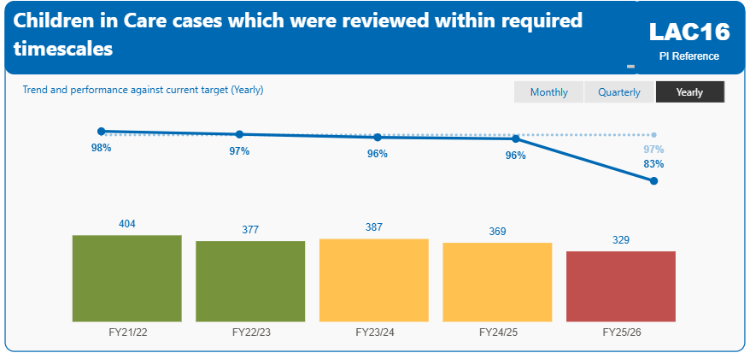
Table 7a - LAC review timeliness

5.1.2 The IRO service conducted 1192 review meetings in 2025/26. An increase of 263 reviews on the previous year, including:
- 181 initial reviews
- 139 second reviews
- 872 subsequent reviews.
5.2 Staged reviews

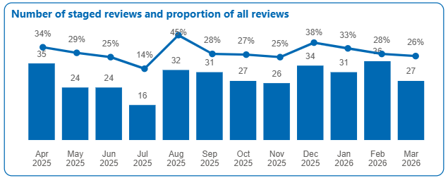
Table 7b – Staged reviews per month
The use of staged reviews is important feature of the IRO Handbook and gives the IRO scope to conduct reviews in a series of meetings (over 20 days maximum) whilst keeping the undertaking made to the child that a review will be started on a specific date. The proportion of staged reviews is not captured nationally, however information shared within the East London region concludes that this is consistent with our neighbours. 89% of staged reviews were completed within 20 days in 2025/26.

5.3 Timeliness of records and authorisations from Review meetings

From April 2026, a revised process has been implemented to strengthen timeliness and accountability. The IRO’s have to complete and record review decisions within 5 working days, which are then signed off by the IRO Service Manager. Team Managers are subsequently notified and expected to authorise within a further 5 working days. This revised approach reduces delay in sharing decisions following review and ensures that children and families receive clear outcomes more promptly. Compliance with these timescales is being actively monitored to drive improved efficiency and performance.

5.4 Participation of children and parent in the Review

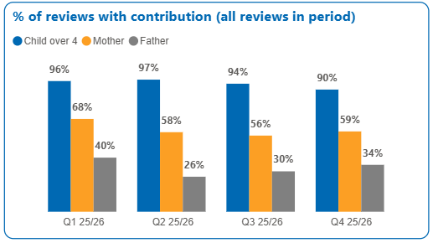
Table 7c – Participation in reviews at end of period
5.4.1 The IRO is required to be satisfied that the Local Authority has been able to establish the child’s wishes and feelings about key issues – and that this has been adequately taken account of. To effectively deliver on this undertaking it is critical the IRO does ensure the both the child and their parents contribute to the review of the care plan.
5.4.2 94% children have in some way contributed to the annual review of their care plan. We constantly strive for ways to achieve our target of 97%. The proportion of children who are happy to be part of their meeting and have confidence to speak for themselves, continues to be a priority. Messages are routinely sent to children in care from care experienced young people to encourage young people to attend and speak from themselves along with seeking support of an advocate.
5.4.3 There has been a gradual decline in recorded participation across all groups, with child participation slightly reduced and parental engagement – particularly fathers - continuing to weaken, remaining the key area for improvement.
6. Quality Assurance

6.1 Independent Reviewing Officer Monitoring
6.1.1 Central to the role of the IRO is the quality assurance of the care plan and review process for each child whilst ensuring the child’s wishes and feelings are given full consideration and the monitoring of progress between reviews.
6.1.2 During 2025/26 IROs were asked to increase their challenge to practice and use of the formal DRP particularly regarding key areas such as: permanence planning; preparation for adulthood including transitions to adult social care and leaving care; updates to care plans; drift and delay in care planning; planning for missing and exploited children; and children without passports. The improved usage of the DRP and the increased escalation of issues to senior managers will enable better understanding of patterns in practice and system challenges and help identify where escalations are most needed and remedial action needs to be taken. Please see graphs below.
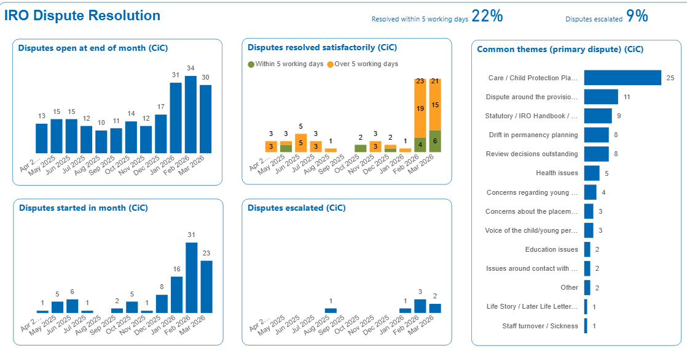
Table 7d formal disputes
6.1 Work with the Virtual School

6.1.1 The IRO Service has continued to work with the Virtual School with focus on the oversight of the children with Education and Health Care Plans and the sourcing of education for children with specific educational needs. This partnership has meant that requests heard at Access to Care and Resources Panel are provided with additional context and support and when needed challenges to SEND Services have been progressed.

6.1.2 Work has also focussed on ensuring the needs of children who are not in full time education for a variety of reasons, have a progression plan that captures their experience, understands their current needs and leads to a plan which will see beyond their 18 birthday. Advice from education advisors in Virtual School continues to be invaluable to strengthening the oversight of the care and pathway plans for such older children

6.2 Work with the Children in Care Health Service

6.2.1 Work has continued with the CIC Health Service ensuring that health actions arising from the initial and review assessments are fully captured in the CIC review outcomes. Work has also focussed on promotion of the importance of on time initial Heath Assessments via inclusion in all notification of appointments of IROs and the importance of older children agreeing to further Heath reviews.

6.2.2 This past year the IRO Service has also contributed to the ensuring the request for provision of relevant information for the medicals required for an adoption decision meets the requirement of the relevant regulations. Information shared at the weekly Permanency Tracker meeting and from the outcomes of the CIC review demonstrate that this pathway and its requirement is now fully embedded.

6.3 Joint work with the Children’s Rights Officer

6.3.1 The close working relationship with the Children’s Rights Officer has continued and has led to the development of specific training for social workers and some of the key placement providers for older children. Feedback from the training has been very positive with the importance of the shared mission to capture the child’s views and experiences whilst appreciating the difference in the respective roles. The training has also included the role of the court appointed Guardian when delivered to social workers.

6.3.2 This past year has also seen the implementation of a non-instructed advocacy service. This is an important contribution for children who cannot provide instruction to an advocate. The IRO service has supported the recruitment and induction of the advocate along with the roll out of the new service.

6.4 Joint work with the Children’s Participation Lead

6.4.1 Work with the Children Participation Lead has continued with a focus on promotion of the Children in Care Council (CICC). Feedback from the new into care children suggests that information about the CICC can get lost in all the information that is provided at this time. Further information sharing is now taking place at the point of the second CIC Review some three months after first becoming a child in care and the recently produced animation clip as an example of the types of activities that can be undertaken in involvement with the CICC is now shared.

6.4.2 In addition to the work with promoting the CICC the IRO Service has provided a link with Leaving Care Forum. Alongside the promotion of the use of the Cove the joint work has enabled the Participation Worker to identify older children who could become involved in wider youth empowerment activities.

6.5 Work with the Permanency Manager

The IRO Service contribution to the weekly Permanency Tracking meeting has continued ensuring the IRO views of progress with securing permanency was noted with any delays being subject to analysis. This tracking also includes evidence of life story work on file. Through this tracking it was agreed increasing in permanency planning meetings being chaired by operational managers was key in improving the permanency planning for our children.

6.6 Work with Youth Justice Service

The IRO Manager has continued to provide Children’s Social Care representation on the YJS Partnership Response to Case Development Panel. This past year the focus of the IRO Service with YJS Service Manager has revisited the arrangement for children who are a child in care by virtue of their Remand status. This has led to redrafting of procedures and work processes ensuring compliance with the relevant regulations and clarity for those children who secure leaving care entitlement whilst being subject to Remand.

6.10 Work with Brokerage and Commissioning

The IRO Service now provides fortnightly updates to the Senior Leadership Placement Review Board on the children who are in high-cost placements. This ensures that Board members are made aware of any issues involved in the care planning for these children including expectations regarding moves, explanations for delays and any open disputes. The IRO Service also provides the views of IROs in respect of referrals made to the Access to Care and Resources Panel about children coming into care, placements changes and individual requests for additional funding.

7. Learning from Complaints

3 complaints were received in respect to the role of the IRO Service or the conduct of the CIC reviews. These were by parents of children in care and were about the IRO not fulfilling duties properly. One of the complaints was partially upheld and the other two were not upheld.

8. Compliments

“She’s the person I have known for longest in my life and she cares! I want to keep in touch when I turn 18” – Child in Care
“I consistently experience the IRO’s commitment to ensuring that children and young people have access to independent advocacy support” – Social Worker
“I’ve worked with a few children allocated to her, and they think highly of her. They’ll usually mention how helpful and supportive she is, describing how she goes above and beyond for them, particularly as there are several professionals involved in their lives, yet she’s usually the professional who’ll visit regularly and would consistently check in on them.” – Social Worker
“She feels really understood and supported by you. She said she wasn’t sure what to expect going into it, but she felt you guided the review in a way that made it clear to everyone that it was about her, and that you also held others to account regarding what they need to do to support her, particularly around her education and therapy, which she feels is urgently needed. You facilitated a genuinely child focused LAC Review that was thoughtful, sensitive and guided by the child’s views, wishes and feelings.” – Child’s Advocate

9. Priorities for 2026/27

- Improvement in the participation of parents and children in reviews.
- Ensure data recording for reviews is correct and that practice and performance for review timeliness are in line with expectations.
- Improvements in the timeliness of the outcomes from review meetings within 5 working days will be a major priority for 2026/27
- Improved proportion of children where permanency has been achieved and there is evidence of life story work on the file.
- Strengthen IRO oversight to ensure all care plans consistently address cultural identity, placement matching, and inclusive participation in reviews.
- All children in our care have a passport.

10. Independent Reviewing Officer Service Action Plan – 26/27

Actions | Timescales
All reviews to be carried out in a timely way which focuses on the child and incorporates shared family decision making. Improved processes now in place to monitor more closely. | This will be reviewed monthly throughout the year and the focus on timeliness - with the quality of plans through Dip Sampling and listening to audio files. Feedback in supervision and Team Meetings to inform practice.  Reported quarterly at Practice and Outcomes Meeting. First feedback due July 2026.
An Increase in the number of DRPs focusing on following key themes:  Attendance at reviews  Children without passports  Care Plans up to date and of a good quality (include cultural identity)  Children who are missing exploitation | This was a focus in 2025/26 and has increased significantly. This will continue to be monitored and reported in the quarterly reports. July 2026
Get feedback from Children in Care Council about the new Azeus forms for review decisions. Forms to be more accessible for all to understand. | Consultation has taken place with IRO’s and forms devised to be simplified. Awaiting consultation with CIC council to gain views before rolling this out. By end of August 26.
IRO service to focus on Family Shared Decision making by ensuring views of children and parents are explicit in all reviews wherever possible. | To be reviewed in September 2026
Hold quarterly meetings with the CIC whole service and IRO’s to ensure best practice for our looked after children. | First meeting booked June 26
Use performance data to monitor disproportionality and outcomes by ethnicity, escalating concerns where there is evidence of unequal access, delays, or poorer outcomes. Ensure care plans address cultural identity. | First deep dive by Oct 26 – cross services approach
Improve participation from parents and carers, particularly fathers. Regular team meeting discussions to maximise ways to do this. | Improvement will be monitored with improvements to be evidenced in the quarterly reports in October 2026.
Improve timeliness of decisions written up by the IRO within 5 days ensuring children’s plans are available to action as soon as possible. | Improvements will be monitored and detailed in the quarterly reports starting October 2026.
All disputes should be responded to within expected timescales. Managers receiving a formal IRO dispute resolution are expected to provide a response or action plan within 5 working days. Where concerns remain unresolved, matters escalated through the dispute resolution process should be responded to within 10 working days. | This will be monitored and form part of the quarterly report.

newham.gov.uk

WE ARE NEWHAM.

