Dysphagia checklist

Are you finding it hard to eat or drink?

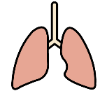 | Have frequent chest infections (aspiration pneumonia)? | YES ☐ | NO ☐
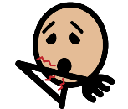 | Cough during or after eating or drinking? | YES ☐ | NO ☐
 | Have a watery/gurgly voice at mealtimes? | YES ☐ | NO ☐
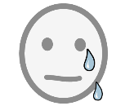 | Get watery eyes when eating or drinking? | YES ☐ | NO ☐
 | Have difficulty chewing foods even when soft? | YES ☐ | NO ☐
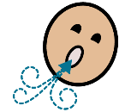 | Become out of breath while eating? | YES ☐ | NO ☐
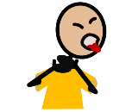 | Experience pain on swallowing? | YES ☐ | NO ☐
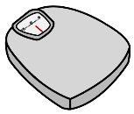 | Have unplanned weight loss? | YES ☐ | NO ☐
 | Find that you are avoiding foods | YES ☐ | NO ☐
- If you experience any of the above ou may benefit from an assessment of your eating and drinking.

- If you have a learning disability you may be eligible for assessment by Speech and Language Therapy at The Newham Health Team for Adults with Learning Disabilities

- If you do not have a learning disability please ask your GP to refer to community Speech and Language Therapy for assessment

