
LBN Adults Market Position
Commissioning Activity Area: | Self-Directed Support Service
Lead Commissioning Officer | Faruk Ahmed
Date | 26th September 2016
Commissioning summary and key actions
Over the past few years ,LBN has increased the level of choice and control that people have over the support and care they receive by introducing personal budgets and self-directed support via Direct Payments.

In line with national and local requirements, The Council wants to encourage a market that is able to deliver a tailored and personalised suite of services that Newham customers want and need in order to make their journey positive, personalised and cost efficient. The Council is committed to fulfilling its role as market facilitator, by seeking to stimulate a diverse provider market where innovation, efficiency and energy is encouraged and where poor practice is actively discouraged. This will be achieved the following:

Key priorities for Self Directed Support Service (SDS):

- For customers to exercise maximum choice and control over their own lives;
- To help customers who take up the offer of direct payment to buy services from a care market that best meets their needs;
- For customers to live independently, and have the maximum choice and control possible over life decisions by ensuring that excellent Information, Advice and Guidance (IAG) services and support services are available;
- To support customers to achieve maximum independence, well-being and dignity by reducing the barriers which prevent them from accessing mainstream services including transport, work, housing, leisure and financial services.
Key actions to help deliver the priorities are:
- Delivering an improved Self Directed Support offer by undertaking a thorough needs and capacity analysis of current activity , including Personal Health Budgets to inform commissioning intentions; and
- To undertake a procurement exercise to appoint Payroll service providers to a Framework Agreement that customers can choose from.

Primary actions in the next 6 months are:

Milestone | Target Date
Need and capacity analysis of current services. | August – September 2016
Wider market analysis and finalise commissioning intentions for a Payroll and Third Party Managed Account Service. | September - October 2016
Seek appropriate internal approvals for procurement and develop service specification for competitive tender of services. | September - October 2016
Identify and agree commissioning intentions for IAG and Direct Payment Support Services. This will include developing a plan to connect customers to wider resources available in the community and extending its scope to deliver proactive health and wellbeing resources. | January 2017
Tender for Framework Agreement for a Payroll Service. | January 2017 – March 2017
Framework Agreement for a Payroll & Managed Account Service go live. | June 2017

What is the identified need/demand in this area?
The Care Act sets out responsibilities in respect of assessing customer needs and the eligibility for publicly funded care and support. Table 1 below displays spend for direct payments during 2013 - 2016. The Council provided 27% of social care spend on direct payment, with the other 73% being provided by independent, voluntary and community organisations. As at September 2016, there were a total of 801 customers in receipt of a Direct Payment.

Table 1: Adult Social Services Expenditure on Service Delivery

 | 2013/14 | 2014/15 | 2015/16
Total Expenditure on Service Delivery | £44,636,500 | £45,976,600 | £49,047,800
Total Spend delivered via Direct Payment | £12,219,270 | £12,476,200 | £13,228,200
% of Spend on Direct Payment | 27% | 27% | 27%

Chart 1 below illustrates the proportion of people using community-based services receiving self-directed support, such as a personal budget for the period 2014 - 2015. Self-directed support gives people more choice over how their care and support works.

Chart 1: Services Users receiving self-directed support service

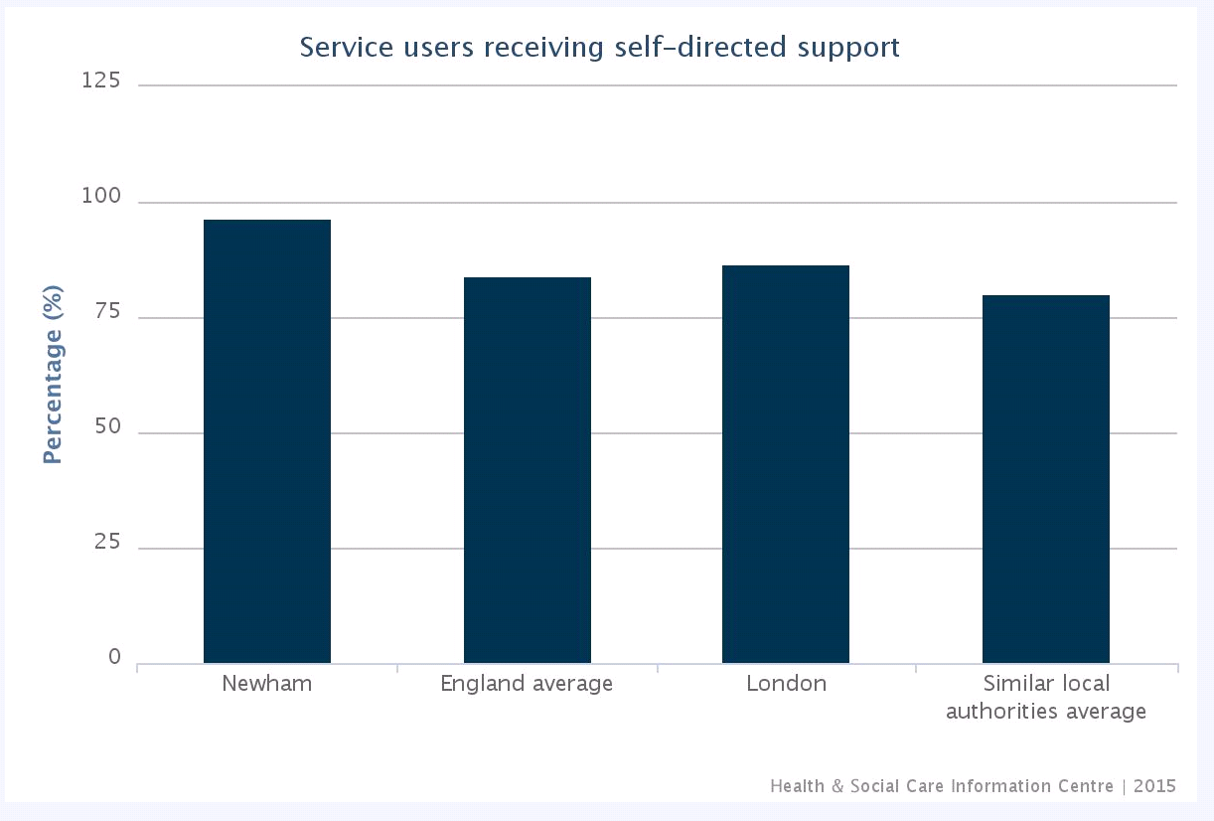

When compared to similar local authorities London boroughs (chart 2), there is a higher take up of customers who are using community-based services that receive their self-directed support as a direct payment. Receiving payments directly lets recipients of care and their carers spend money on care and support in ways and at times that make sense to them.

Chart 2: People Receiving Direct Payment Across England
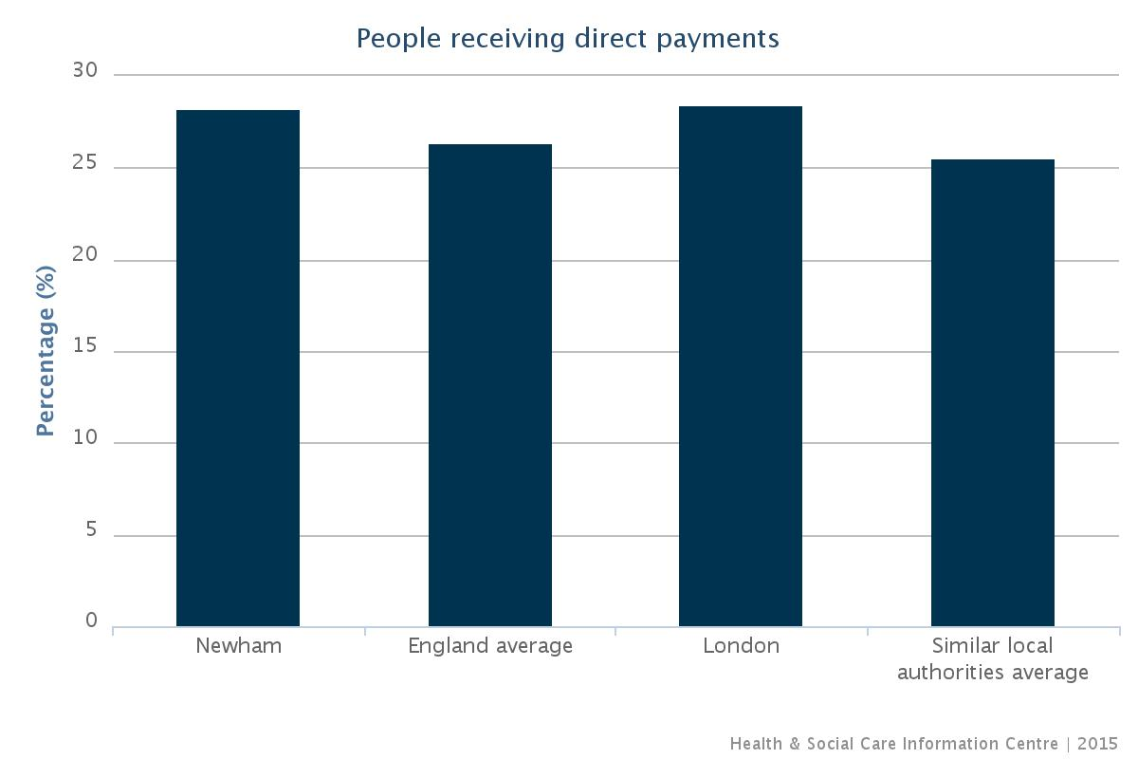

Similarly, carers choose to receive their self-directed support as a direct payment for support direct to them. This enables carers to spend money on care and support in ways and at times that make sense to them.

The chart below compares carers receiving direct payments across England.

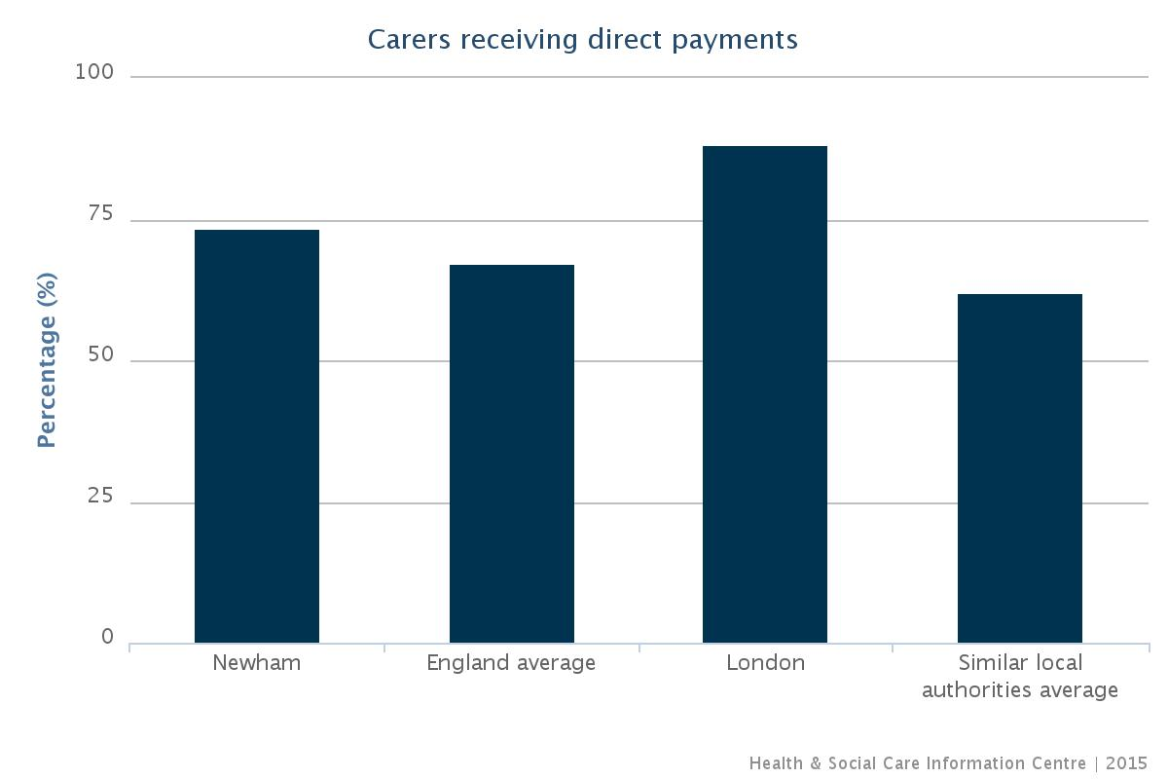

As demand for personalised services increases around community based services, it will enable the Council to work towards it’s aspirations under economic and personal resilience. This will be achieved by stimulating the local economy by providing a variety of employment opportunities for local people. Also enabling people to take ownership of their challenges within a supportive community environment and make informed, positive and long-term decisions that meets their care and support.

Is there a LBN or jointly commissioned service currently in place? | Yes
Current contractual status and performance
Newham Adult Social Care currently hold three contracts that deliver four types of services. The contracts are delivered through in-house service and by external providers.

The table below displays an overview of current contracts supporting customers through SDS journey for the period 1st August 2015 – 31st July 2016.
Service Type | Current Provider | Contract Type | No. of Customers Supported
Information, advice and support. | London Borough of Newham | In-House Service - SDS Monitoring Team. | 237
Information, advice and support. | Vibrance. | Block Contract. | 110
Third Party Managed Account to hold and administer funds | Vibrance, Hestia | Customer contract with Provider – customer choice, arranged through SDS Monitoring Team. | 134
In-House Third Party Managed Account to hold and administer funds. | London Borough of Newham | Customer contract with Provider – customer choice, arranged through SDS Monitoring Team. | 241
A full Payroll service. | Vibrance, Hestia | Customer contract with Provider – customer choice, arranged through SDS Monitoring Team. | 103

Table 2: The table below shows activity of the referrals received by the Self Directed Support Monitoring Team for the period 1st April 2016 – 31st July 2016.

 | Referral Received
Activity | April | May | June | July
Referrals in Progress | 14 | 14 | 17 | 23
Customer declined Direct Payment | 1 | 0 | 2 | 0
Customer opted for Pre Paid Card | 14 | 8 | 5 | 6
Opted for 3rd Party Managed Account | 12 | 9 | 6 | 11
Total | 41 | 31 | 30 | 41

How well does the current provision meet the identified need
The current contracts for the support service, payroll and managed account service appears to be working well and meeting the objectives set out by Adult Social Services. However, there is a clear need to increase choice of providers, and to ensure an up-to date service specification for Support Service, Payroll and Managed Account Service is developed. A new Framework Agreement for a Payroll Service will place an emphasis on transparency of payroll and cost and quality of service provided, ensuring a smooth journey for customers.

Market Status and Development

Current provider market
There are a range of suppliers providing a Payroll and Managed Account services to customers taking up the offer of direct payments, both locally and nationally. This market is likely to increase due to the Governments personalisation agenda and no market development is required at this time. However, gathering market intelligence will be required to ensure a quality and value for money service is provided to customers.

Information and data gathered by commissioners indicated that there are a range of providers in Newham and neighbouring boroughs that provide information, advice and support service for Direct Payments and Personal Health Budgets. However, Personal Health Budgets is a relatively a new developing market and more intelligence gathering will be required to map out the market both locally and nationally.

Information gathered from the market place for a Payroll and Managed Account service indicates that this is a sustainable market both locally and nationally. Providers offer common products and therefore there is little regional difference. This is a developed market and is continuing to develop with the introduction of new technology for efficiency and smooth customer journey. It is anticipated this market will grow both locally and nationally in line with Governments personalisation agenda.

Gaps in current provision/desired market
Commissioners have identified that there are no gaps in provision for this market. There are a small number of providers offering support for Personal Health Budgets. It is expected there world be sufficient interest and capacity within the current market to meet the identified needs.

Opportunities/Limitations in supporting future market development
Limitations:
- Currently there are no identifiable limitations as this market is continuously adapting to Government and Local Authority personalisation agenda. As the contract for services is between Providers and customers it is in the Providers interest to cater to customers needs with a cost efficient and value for money service.
Opportunities:
- Variance in unit cost amongst individual providers offers commissioners an opportunity to develop the market to increase equity and quality in service delivery;
- Framework Agreement of providers will encourage provider development within limited resources and stimulate the market; and
- Call-off from the list is designed to incentivise providers to improve their performance.

Commissioner intentions for future of the service
Improving Choice and Quality of Self Directed Support Service

- Through the delivery of a Framework Agreement for Approved Payroll Providers by July 2017;
- By monitoring individual outcomes for customers as a result of choosing a Direct Payment;
- Listening to customers to improve services;
- Explore opportunities for utilising new and existing services to support Individuals with a Personal Health Budget; and
- Review the overall design, content and functionality of the current external Self Direct Support Service and LBN In-House Self Directed Support Service to identify longer term commissioning intentions;

Increasing the usage of Direct Payment

- Support frontline staff to promote the benefits of Direct Payments;
- Improve the consistency and quality of information available to customer regarding Direct Payments;
- Work with providers to promote the advantages of personalisation and self directed support;
- Identify and minimise barriers to accessing Direct Payments and develop individuals skills; and
- Minimise customer barriers to take up Direct Payment and maximise people abilities.

Short, medium and long term action plan to move towards desired market status, and meet commissioning intentions
Timeframe | Key actions to be taken
Short Term (6 months) | - Mapping of service requirement for Support Service (Information, Advice & Guidance), Payroll and Third Party Managed Account Service relating to Direct Payments;  - Development of procurement documents; and  - Implement the new Framework Agreement for a Payroll Service.  - Identify commissioning intentions for AIG and Direct Payment Support Services  - Gather market intelligence for Personal Health Budget. This is to:  - Identify demand for the service;  - Identify cost of Personal Health Budget – this is due to the specialist nature of the service.  - Support Service (Information, Advice & Guidance)
Medium Term (1 year) | - Deliver commissioning intentions for AIG and Support Services.  - Contract Monitoring of new Framework Agreement for a Payroll Service for the provision of Direct Payment; and  - On-going need and capacity analysis.
Long Term (1-3 years) | - Achieve equity of performance and outcome amongst providers; and  - Review Framework Agreement with all stakeholders.

