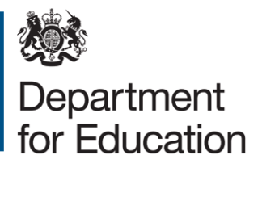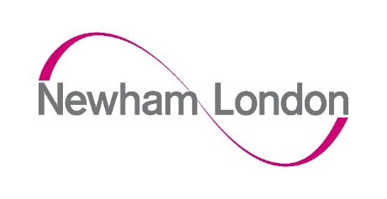

London Borough of Newham:
Application form for free school meals for children from families with no recourse to public funds (NRPF)
Please complete this application form if you are a family with NRPF and would like to apply for free school meals.
To complete this form, applicants should complete all sections.
When completed, please ensure the declaration at the end of the application is also signed.
Further information relating to this extension can be found in the free school meals guidance for schools and local authorities.

Child’s details
First name(s) of child
Surname of child
Date of birth of child (dd/mm/yy)
Nationality of child
Home address of child

Parent/carer’s details
First name(s) of parent/carer
Surname of parent/carer
Relationship to child
Nationality of parent/carer
Address of parent/carer including post code
Please tick or highlight the immigration category you are applying under.
- Zambrano

- Chen

- Article 8 of the ECHR

- Section 4 of the Immigration & Asylum Act 1999

- BN(O) Passport holder

- Spousal visa holder

- Work visa holder

- Student visa holder

- Other

If you ticked “other” in the above section, please explain further here and provide evidence:
Evidence of status you are providing to support your application:
- Zambrano or Chen carers
In many (but not all) cases, the family will be able to show a derivative residence card. If they do not hold this, they must be able to show that:
  - the carer or parent is not a British citizen
  - the child is a British citizen
  - the carer is a direct relative or legal guardian of the child, and they have the primary responsibility for the child
  - there are no other members of the carers’ family in the UK or the European Economic Area (EEA) who could look after the child

- Article 8 of the European Convention on Human Rights (ECHR)
Families will be able to provide a letter from the Home Office granting them leave to remain in the UK or a biometric residence card.

- Section 4 of the Immigration and Asylum Act 1999
Families will be able to provide a letter from the Home Office or local authority confirming Section 4 support or an ASPEN card.

- British National (Overseas) passport holders
Families will be able to show either a current BN(O) passport or visa.

- Spouse, work or student visa holders
Families will be able to show their visa.

Evidence of income
To be eligible for free school meals, a families’ annual household income must be no higher than the following:
- £22,700 for families outside of London with one child
- £26,300 for families outside of London with two or more children
- £31,200 for families within London with one child
- £34,800 for families within London with two or more children
This includes any wider income or support you may be receiving in addition to any earnings from employment.
To verify this, we suggest you provide one of the following:
- Payslip from employer

- P60

- Bank statement

- Letter from their bank

- Letter from their employer

- Letter from their employer

- Letter from the local authority confirming support if applicable

Are you employed?
If you have a partner, are they employed?
Is your annual household income, including earnings from employment and any wider support you may be receiving, less than the maximum income thresholds listed above?

Declaration of applicant
I (Full Name) ..........................................................................................................
of (Full Address) .................................. .........................................................................................
confirm that the information I have provided above is accurate and true.
I agree that the information I have provided can be shared with the Department for Education for the purposes of assessing eligibility for a free school meal.

Parent/Carer/Guardian with legal responsibility for care of the child
- Signed
- Print name
- Date

How to submit a completed application
  - By email to free.schoolmeals@newham.gov.uk enter the subject as NRPF FSM – the completed and signed application form can be photographed or scanned and then attached to the email.
OR
  - By hand to your social worker or child’s school (only if in Newham)
OR
  - Post to Pupil Services (NRPF Free School Meals),
LB Newham, 1000 Dockside Road, London E16 2QU
Pupil Services aim to process all applications within 48 hours of receipt.
Notification of the outcome
Applicant’s will receive the outcome of their application in writing and this will be sent to child’s current school, where this is in Newham. If the school is outside of Newham the family will need to give the outcome to the child’s school.

